|  |
| --- |
| Threatened Species Assessment |
| *Victaphanta compacta*  Otway Black Snail |

## Taxonomy

*Victaphanta compacta* (Cox & Hedley, 1912)

## Current conservation status

Listed as threatened under the *Flora and Fauna Guarantee Act 1988* (SAC 2001).

Categorised as Endangered in the 2009 Advisory list of threatened invertebrate fauna in Victoria (DSE 2009).

## Proposed conservation status

Endangered in Australia

Criteria B1ab(iii)+2ab(iii)

## Species Information

### Description and Life History

The body of the snail is grey-blue to black. The shell is spherical with four whorls and varies from a glossy dark brown to black with varying tinges of yellow-brown on the inner whorl. The shell has a maximum diameter of 28mm and is positioned towards the tail of the body. The shell is thin, light weight and moderately flexible and composed mostly of conchin. The Otway Black Snail can be distinguished from other species of *Victaphanta* because of its specific geographic range, globulous shaped shell, lack of an orange frill around its foot and an absence of orange mucus.

The Otway Black Snail is partially nocturnal. It is carnivorous, feeding on other snails, slugs, earthworms and soft bodied insect larvae but is not cannibalistic. It has no jaw as found in herbivorous snails but has long, sharp, backward pointing teeth arranged in v-shaped rows on the radula (underside of the foot of the snail) which hold the prey while it is devoured. The Otway Black Snail lays eggs in clumps; eggs are white, 2-3 mm in diameter and have hard calcareous shells (Smith 1970).

### Generation Length

The generation length of the Otway Black Snail is inferred to be 3 to 5 years. There is no published information on the longevity of the Otway Black Snail, but studies of other members of the Rhytitidae family indicate the life span may be from 2-8 years.

### Distribution

This species is endemic to Victoria and occurs in the Otway Ranges.

### Habitat

The Otway Black Snail is only found in Wet Forest and Cool Temperate Rainforest in the Otway Ranges. Within suitable forest types the Otway Black Snail shows no particular habitat preference. It can be found equally on wet forest ridgelines, cool temperate rainforest gullies and slope ecotones. The preferred micro habitat is at the base of trees and tree-ferns and within deep leaf litter. It is less likely to be found in log debris and is unlikely to be found 2 metres above ground level (Burrell et al. 2007).

### Threats

The Otway Black Snail is reliant on moist conditions and is susceptible to desiccation when in dry conditions (Smith 1971). Prolonged periods of drought which dry out normally moist habitat may have an adverse impact on this species by reducing the extent of available habitat. The greatest threat to the wet forest malacofauna of the Otways is climate change, with preliminary prediction being for a notable reduction of such habitat types by 2080 (Miles 2010).

There has been damage to and loss of the preferred habitat types as a result of Myrtle Wilt and human activities that disturb the forest floor and overstorey vegetation. It should be noted that native forest timber harvesting on public land has been phased out in the Otways since 2008. Harvesting on private land and in plantations continues in parts of its range. The Code of Practice for Timber Production 2014 (Code) regulates timber production on public and private land, including native forest and plantations. Protections for waterways and rainforest are included in the Code.

The narrow distributional range of the taxon makes it prone to extinction as a result of stochastic events. Because the Otway Black Snail is only found in certain areas of the Otway Ranges and nowhere else in the world, it is susceptible to catastrophic bushfire events.

## IUCN Criteria

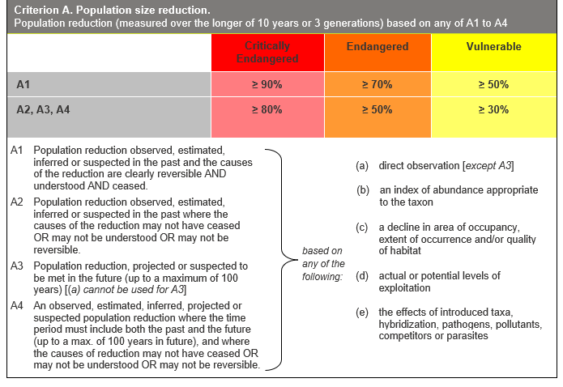

## Evidence:

**Ineligible under Criterion A**

Population reductions over the past 10 to 15 years, the future 10 to 15 years or any 10 to 15-year period are suspected to be less than 30%.

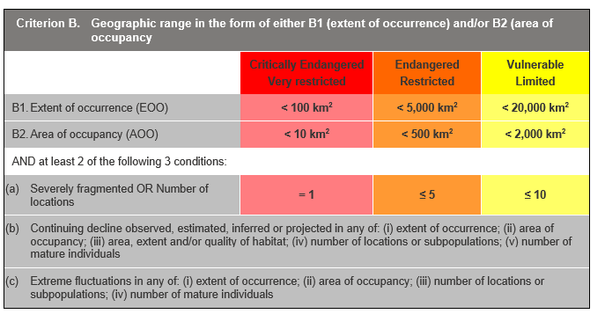

## Evidence:

**Eligible under Criterion B1 as Endangered**

The Extent of Occurrence (EoO) across the taxon's range is estimated to be 840 km², based on accepted, post-1970 records from the Victorian Biodiversity Atlas (VBA).

The taxon is estimated to be severely fragmented. Considering the taxon’s low vagility, recovery is typically slow and can take decades, depending on distance from source and demographics**.** Such fragmentation precludes the possibility of recolonisation in the event of local extinction.

It is estimated to have 2 locations and is estimated to have a continuing decline in (iii) above. It has been estimated that only 5% of Australia is suitable for many native land snails and that the conservation of remaining habitat is critical to protect suitably moist fragments (Clarke and Spier-Ashcroft 2003). Whilst the consequences of complete habitat loss for land snail conservation are obvious, there are other subtle factors at play in modified landscapes that will influence the species assemblage present. Altered fire regimes and droughts driven by climate change are the most important factors underpinning likely longer-term declines in extent and quality of habitat.

**Eligible under Criterion B2 as Endangered**

The Area of Occupancy (AoO) across the taxon's range is estimated to be 420 km², based on 2 x 2 km grids derived from accepted, post-1970 records in the VBA. As above, the taxon is estimated to be severely fragmented, has 2 locations and has a continuing decline in habitat.

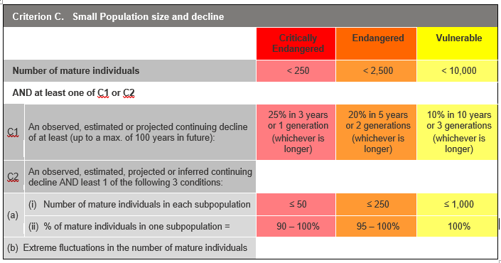

## Evidence:

**Ineligible under Criterion C**

It is estimated that there are 15,000 to 25,000 mature individuals, which exceeds the thresholds for criterion C.

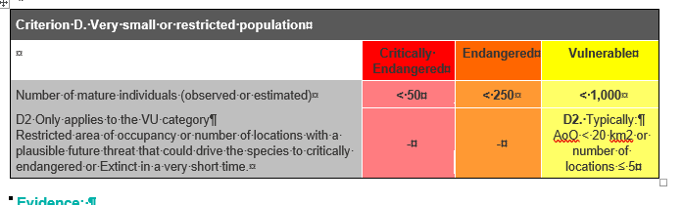

## Evidence:

**Ineligible under Criterion D**

It is estimated that there are 15,000 to 25,000 mature individuals.

### Criterion E (Quantitative Analysis) was not addressed as the taxon does not have a detailed Population Viability Analysis.

## References

Burrell, C., Scott, B., and Yen, A.L. (2007) Habitat preferences of the Otway Black Snail *Victaphanta compacta* (Cox and Hedley, 1912) (Rhytididae). *The Victorian Naturalist* Vol. 124 (4), 204-209.

DSE (2009) *Advisory list of threatened invertebrate fauna in Victoria - 2009.* Department of Sustainability and Environment, Melbourne. (Retrieved from https://www.environment.vic.gov.au/__data/assets/pdf_file/0016/50452/Advisory_List_of_Threatened_Invertebrate_Fauna_2009_FINAL_Sept_2009.pdf)

IUCN (1996) Mollusc Specialist Group. 1996. *Victaphanta compacta*. The IUCN Red List of Threatened Species 1996: e.T22951A9402284.http://dx.doi.org/10.2305/IUCN.UK.1996.RLTS.T22951A9402284.en.

Miles, D. (2010) Quantifying and Assessing Uncertainty in Climate Change Projections for Cool Temperate Rainforests of South-eastern Australia. Master's thesis. University of Melbourne.

SAC (2001). Flora and Fauna Guarantee Scientific Advisory Committee: Final Recommendation on a Nomination for Listing. Nomination No. 522 *Victaphanta compacta*.

Smith, B.J. (1970) Notes on the anatomy of *Victaphanta atramentaria* (Shuttleworth) and *Vicaphanta compacta* (Cox and Hedley) and the designation of a neotype for *V. atramentaria*. *Journal of the Malacological Society of Australia*, 2: 13-21.

Smith, B.J. (1971). Carnivorous Snails of the Family Paryphantidae, *Australian Journal of Natural History*, 71: 55-58.