Introduction
Biodiversity Response Planning (BRP) is a long-term area-based planning approach to biodiversity conservation in Victoria. It is designed to strengthen alignment, engagement and participation between government, Traditional Owners, non-government agencies and the community.
DELWP Regional staff have been working with stakeholders on actions to conserve biodiversity in specific landscapes, informed by the best available science and local knowledge.
These Fact Sheets capture a point in time, reflecting data and knowledge available in 2020. They provide information for many (but not all) landscapes across Victoria, containing general information on the key values and threats in each area, as well as the priority cost-effective actions that provide the best protection of biodiversity. Fact Sheets are intended to provide useful biodiversity information for the community, non-government and government organisations during project planning and development.
Further information and the full list of Fact Sheets is available on the Department’s Environment website.

Landscape description
This 826,000ha area has significant native vegetation (72% cover) and has significant public land (86%). It is defined primarily by the public land boundaries of Wyperfeld National Park and Big Desert State Forest. The eastern boundary takes in Bronzewing Flora and Fauna Reserve (FFR), Wathe FFR and significant reserves around Patchewollock. The adjoining private land (1km buffer) is also included.
There is a minor overlap with the Cowangie landscape in the north and a major overlap with the Wimmera River focus landscape. For more information on these landscapes, please refer to the full list of Fact Sheets.

Cultural importance
We recognise that the entire landscape has high cultural value for Traditional Owners. Landscapes identified as having “notable” cultural importance is based on the density of recorded cultural heritage sites and knowledge shared by Traditional Owners. We also recognise that there are locations important to Traditional Owners not within these landscapes.
Notable cultural importance for the Barenji Gadjin Land Council Aboriginal Corporation.

Stakeholder interest
As part of the Biodiversity Response Planning process, in October 2020 stakeholders were asked to nominate focus landscapes and actions of interest. DELWP, Hindmarsh Landcare Network, South East Mallee Landcare Network, Murrayville Landcare Group and Parks Victoria nominated Wyperfeld - Big Desert.
Possible future investment/project development in this landscape will be available to any interested stakeholders in addition to those who nominated this landscape.
Specific stakeholder interests identified through the engagement process within this landscape include:
- Parks Victoria Conservation Action Plan assets - Heathlands and Mallee Heathlands, Mallee Triodia, Lowan Broombush and Swales, Semi Arid Woodland (Wirrengren / Outlet Creek), Inland Riverine Forest (Wirrengren / Outlet Creek). Total Grazing Management, adjacent Ramsar site, Semi-arid Woodland restoration (rabbits, goats, kangaroos, revegetation, vegetation monitoring) and Major Mitchell nesting enhancement.
- Mallee Catchment Management Authority, Regional Catchment Strategy priority landscapes - 13. Wyperfeld / Big Desert Dunefields, 14. Outlet Creek and Wirrengren Plain, 15. Bronzewing Dunefields, 16 Wathe Dunefields.
- Department of Environment, Land, Water and Planning, significant area of public land - Big Desert State Forest. Areas of interest within the landscape are Northern boundary of Big Desert State Forest, support fire management actions.

Community interest
Community interest in biodiversity conservation including Landcare interest in connectivity between public land blocks was identified for this area through the consultation process.

 | Habitat Distribution Models identify 493 species with more than 5% of their Victorian range in this landscape area | Traditional Owners, stakeholders and community groups identified the following species of interest
 | 367 Plants, 35 species with more than 50% of Victorian range in area. Notably:  - Shining Spyridium (endangered, 64% of Victorian range in area)  - Azure Sun-orchid (vulnerable, 72% of Victorian range in area) | - Buloke woodlands  - Semi-arid Woodlands  - Orchids
8 Mammals, 7 species with more than 20% of Victorian range in area. Notably:
- Silky Mouse (near threatened, 61% of Victorian range in area)
- Mitchell’s Hopping-mouse (near threatened, 59% of Victorian range in area)
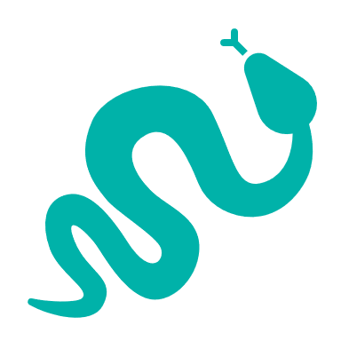 | 38 Reptiles, 35 species with more than 10% of Victorian range in area. Notably:  - Mallee Worm Lizard (vulnerable, 93% of Victorian range in area)  - Masters’ Snake (endangered, 93% of Victorian range in area)  - Rosenberg’s Goanna (endangered, 51% of Victorian range in area)  - The Heath Skink is also known only from this area | - Bandy Bandy  - Mallee Worm Lizard
 | 79 Birds, 40 species with more than 10% of Victorian range in area. Notably:  - Australian Bustard (critically endangered, 61% of Victorian range in area)  - Malleefowl (vulnerable, 45% of Victorian range in area) | - Threatened Mallee Birds – Mallee Emu-wren, Black-eared Miner, Red-lored Whistler, Striated Grasswren, Malleefowl, Regent Parrot  - Pink Cockatoo
1 amphibian. Notably:
- Southern Bullfrog (6% of Victorian range in area)

Strategic Management Prospects
Strategic Management Prospects (SMP) models biodiversity values such as species habitat distribution, landscape-scale threats and highlights the most cost-effective actions for specific locations. More information about SMP is available in NatureKit.

Additional threats
Threats identified (in addition to those modelled in SMP) through the consultation process were:
- alterations to hydrology
- land salinisation
- soil erosion
- habitat degradation due to extremes of climate and weather
- lack of regeneration in some vegetation communities
- recreational activities causing fragmentation
- loss of vegetation, and erosion
- legacy use of public land
- private land use impacting biodiversity
- inappropriate land use planning
- inappropriate fire regimes (planned burning and bushfires)

Which landscape-scale actions are most cost-effective in this landscape?
Some areas of this focus landscape (coloured areas on the map) have highly cost-effective actions which provide significant benefit for biodiversity conservation
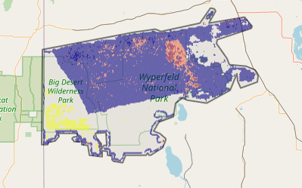
The SMP priority action which ranks among the top 3% for cost-effectiveness of that action across Victoria for much of the area (>10,000ha) is Control goats. The SMP priority actions which rank among the top 10% are in order:
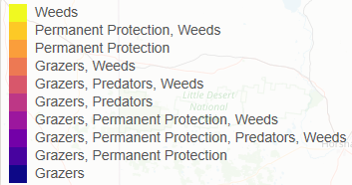
 | Control goats 447,221ha
 | Control overabundant kangaroos 103,477ha
 | Control weeds 67,149ha
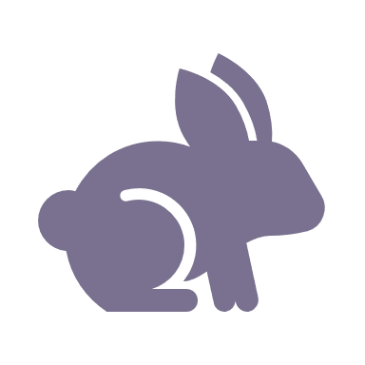 | Control rabbits 20,852ha

Of the top 10% of cost-effective actions, control all grazers provides the most cost-effective biodiversity benefits when considering all flora and fauna.
Additional actions suggested for this landscape through the nomination process are:
- control of weeds, foxes, goats, overabundant kangaroos, deer and rabbits
- revegetation
- managing off-road access and impacts
- fire management

The most cost-effective action for flora and fauna
Plants, birds, mammals, reptiles and amphibians – Control goats

For a further in depth look into SMP for this landscape please refer to NatureKit.

