Introduction
Biodiversity Response Planning (BRP) is a long-term area-based planning approach to biodiversity conservation in Victoria. It is designed to strengthen alignment, engagement and participation between government, Traditional Owners, non-government agencies and the community.
DELWP Regional staff have been working with stakeholders on actions to conserve biodiversity in specific landscapes, informed by the best available science and local knowledge.
These Fact Sheets capture a point in time, reflecting data and knowledge available in 2020. They provide information for many (but not all) landscapes across Victoria, containing general information on the key values and threats in each area, as well as the priority cost-effective actions that provide the best protection of biodiversity. Fact Sheets are intended to provide useful biodiversity information for the community, non-government and government organisations during project planning and development.
Further information and the full list of Fact Sheets is available on the Department’s Environment website.

Landscape description
This 74,000ha area has a small amount of native vegetation (13% cover) and a small amount of public land (5%). It includes a series of Flora and Fauna Reserves along the Yarrara Ridge and the surrounding private land which together connects to and has a minor overlap with the Murray Sunset National Park in the south. The area is buffered a minimum of 1km from any private land. You can find further information on the Murray Sunset focus landscape in the full list of Fact Sheets.

Cultural importance
We recognise that the entire landscape has high cultural value for Traditional Owners. Landscapes identified as having “notable” cultural importance is based on the density of recorded cultural heritage sites and knowledge shared by Traditional Owners. We also recognise that there are locations important to Traditional Owners not within these landscapes.
Cultural importance for the First People of the Millewa Mallee Aboriginal Corporation.

Stakeholder interest
As part of the Biodiversity Response Planning process, in October 2020 stakeholders were asked to nominate focus landscapes and actions of interest. First People of the Millewa Mallee, Mallee Catchment Management Authority, Trust for Nature, Parks Victoria and Mildura Rural City Council nominated Yarrara Ridge.
Possible future investment/project development in this landscape will be available to any interested stakeholders in addition to those who nominated this landscape.
Specific stakeholder interests identified through the engagement process within this landscape include:
- Parks Victoria, Conservation Action Plan assets – Semi-arid Woodland. Focus more on reserves and areas immediately adjacent, revegetation work within reserves as well as around.
- Mallee Catchment Management Authority, Regional Catchment Strategy priority landscape – 2. North west woodlands, Climate Change priority corridor 1: West Millewa. Focus on the restoration (e.g. connectivity of and regeneration within isolated remnants) of high value habitat for priority species outcomes.
- Mildura Rural City Council – opportunity for Semi Arid Woodland regeneration and increased fauna species population relating to this Ecological Vegetation Class.

Community interest
There was no specific community interest in biodiversity conservation identified for this area through the consultation process.
 | Habitat Distribution Models identify 22 species with more than 5% of their Victorian range in this landscape area | Traditional Owners, stakeholders and community groups identified the following species of interest
 | 22 Plants with more than 5% of Victorian range in area. Notably:  - Grey Wrinklewort (endangered, 22% of Victorian range in area)  - Blue-bush Daisy (endangered, 11% of Victorian range in area) | - Buloke woodlands  - Semi-arid woodlands
 |  | - Bandy-bandy
 |  | - White-browed Tree Creeper

Strategic Management Prospects
Strategic Management Prospects (SMP) models biodiversity values such as species habitat distribution, landscape-scale threats and highlights the most cost-effective actions for specific locations. More information about SMP is available in NatureKit.

Additional threats
Threats identified (in addition to those modelled in SMP) through the consultation process were:
- alterations to hydrology
- land salinisation
- soil erosion
- habitat degradation due to extremes of climate and weather
- lack of regeneration in some vegetation communities
- recreational activities causing fragmentation
- loss of vegetation, and erosion
- legacy use of public land
- private land use impacting biodiversity
- inappropriate land use planning
- inappropriate fire regimes (planned burning and bushfires)

Which landscape-scale actions are most cost-effective in this landscape?
Some areas of this focus landscape (coloured areas on the map) have highly cost-effective actions which provide significant benefit for biodiversity conservation.
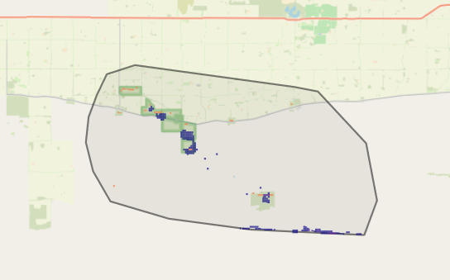
The SMP priority actions which rank among the top 3% for cost-effectiveness of that action across Victoria cover <1,000ha of the area and are:
Control overabundant kangaroos 628ha
Control goats 390ha
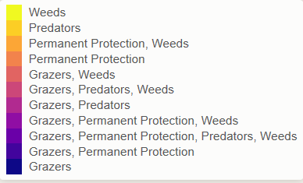
Of the top 10% of cost effective actions, control rabbits provides the most cost-effective biodiversity benefits when considering all flora and fauna.

Actions suggested for this landscape through the nomination process are:
- control rabbits, weeds, foxes and cats
- revegetation
- permanent protection
- supplementary revegetation
The most cost-effective action for flora and fauna
Plants – Control rabbits
Mammals, birds and reptiles – Combined cat and fox control

For a further in depth look into SMP for this landscape please refer to NatureKit.
