Volunteering Naturally

Understanding Victoria’s Environmental Volunteers 2024

Table of Contents

About environmental volunteering and Volunteering Naturally 1

Volunteering Naturally 2024 3

Key observations 8

Where Victorians volunteer 9

Publication information 12

# About environmental volunteering and Volunteering Naturally

Victoria has a strong history of environmental volunteering, with volunteers contributing enormously to improving our environment, our local communities, and our economy.

Volunteering Australia defines volunteering as “time willingly given for the common good and without financial gain.” Environmental volunteering is volunteering in and for our natural environment and encompasses a diverse range of environmental and sustainability activities carried out by individuals and community groups.

## About Volunteering Naturally 2024

Delivered annually since 2019, Volunteering Naturally is a collation of data about active environmental volunteer groups and organisations in Victoria.

Volunteering Naturally recognises the variety of types of environmental volunteering. This includes regular volunteering activity, large annual volunteering events, community place based models of volunteering in nature and sustainability/climate action activities.

It also provides the opportunity to communicate and celebrate the collective effort of all Victorian environmental volunteers.

## Data collection during 2024

For the 2023–24 financial year, we received data from 65 per cent of the groups and organisations involved in environmental volunteering in Victoria. This was a decrease from 2022–23 in which we received 70 percent of the data.

The data includes their location, the number of volunteers and the volunteer hours contributed. Data is sourced through financial year reporting, grant applications and a short survey.

Data has not been assumed for groups that did not respond, and we note that capturing contributions, especially through advocacy and wildlife rescue and rehabilitation, presents challenges. These factors make the collated volunteer numbers and hours provided an underestimate of the effort across the sector.

# Volunteering Naturally 2024

## Annual snapshot of Victoria’s environmental volunteer groups

Figure : Annual snapshot of Victoria’s environmental volunteer groups

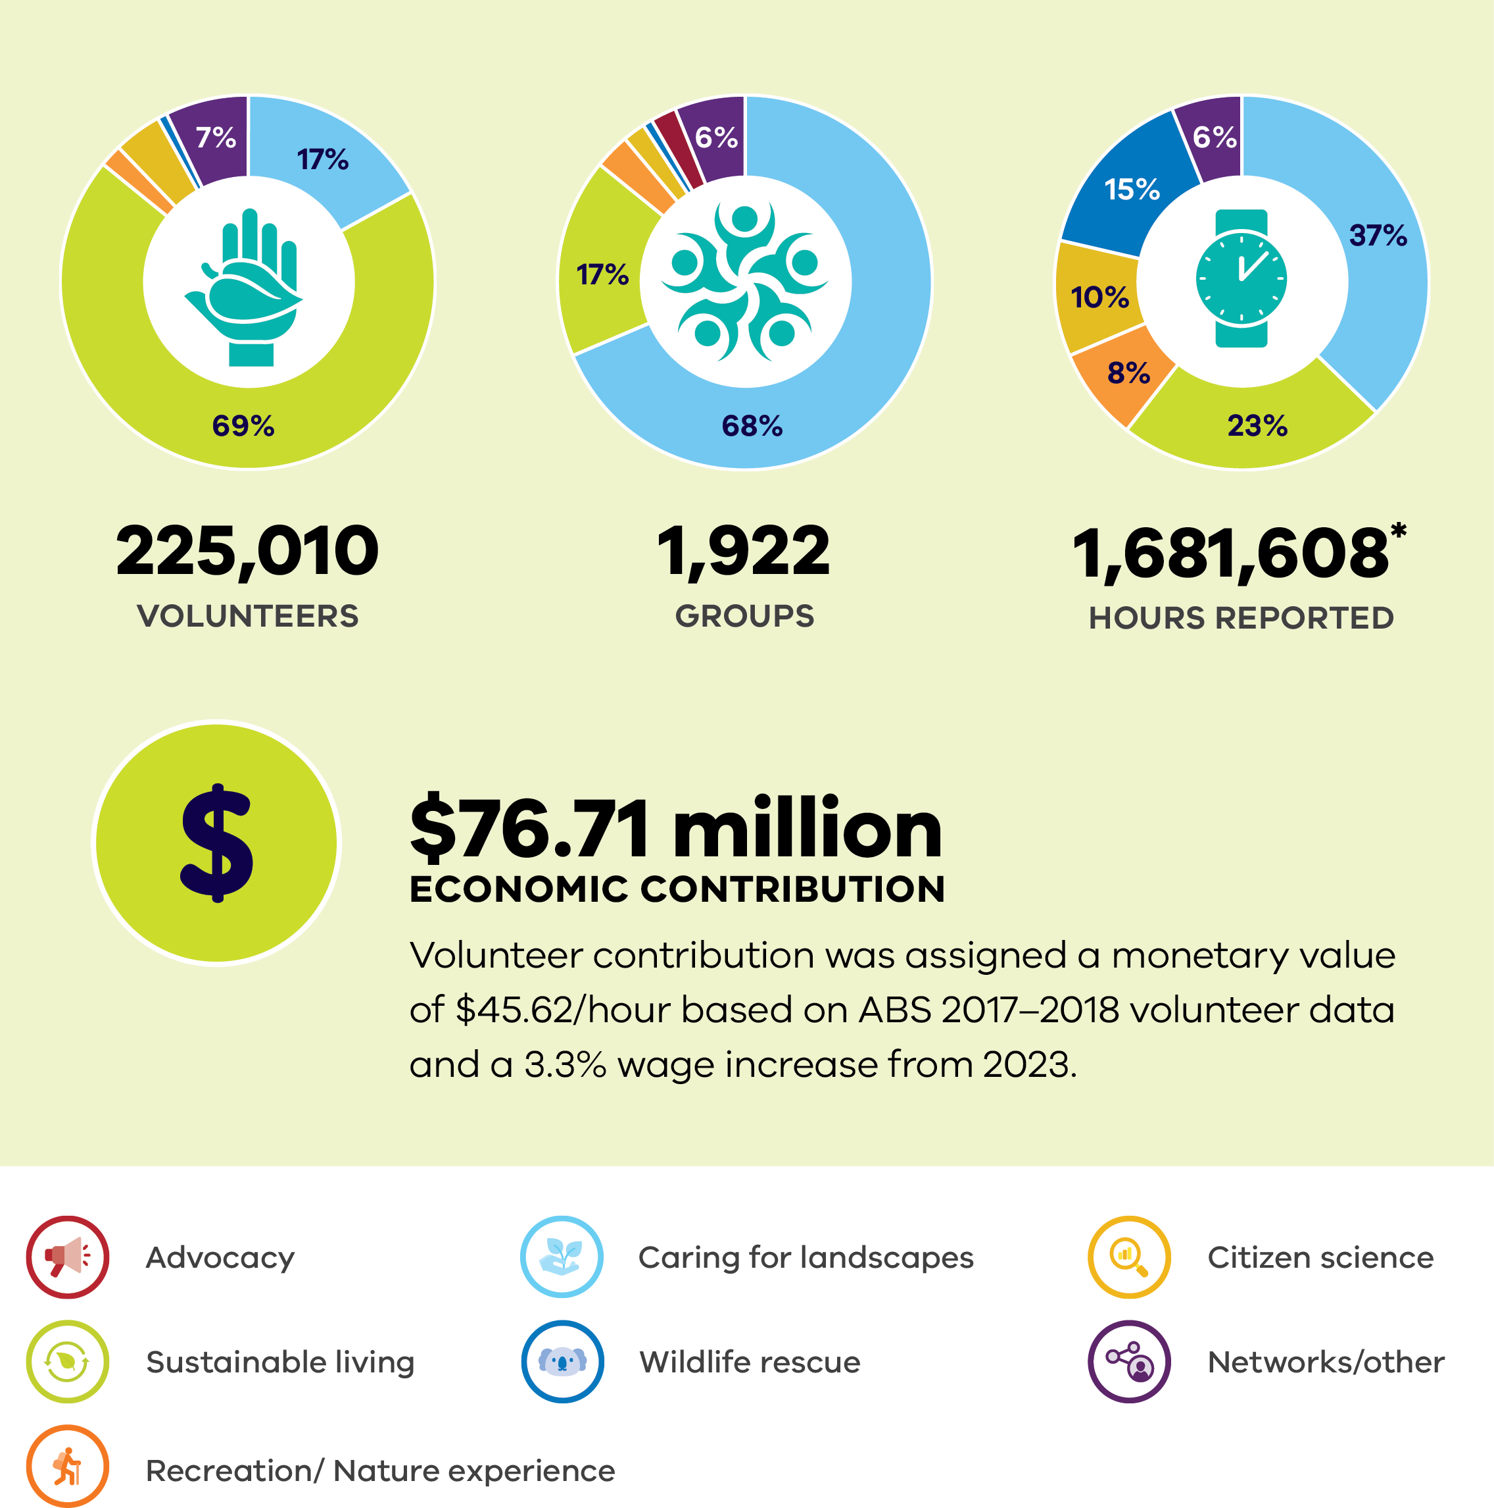

In 2024 there were:

* **225,010 volunteers**
* **1,922 groups**
* **1,681,608 hours reported** (Note: 65% of known active groups captured and reported their data. Volunteer contribution is based on data from the most recent financial year.)
* **$76.71 million economic contribution.** Volunteer contribution was assigned a monetary value of $45.62/hour based on ABS 2017–2018 volunteer data and a 3.3% wage increase from 2023.

Table : Volunteer groups in Victoria data

| Name of Volunteer Group Category | Number  of  Groups | Percentage of  groups | Number  of Individuals | Percentage of individuals | Number  of  hours | Percentage of  hours |
| --- | --- | --- | --- | --- | --- | --- |
| **Caring for Landscapes  total** | 1309 | 68 | 37571 | 17 | 624253 | 37 |
| **Sustainable Living total** | 323 | 17 | 155913 | 69 | 391844 | 23 |
| **Recreation/ Nature Experience** | 62 | 3 | 5104 | 2 | 131273 | 8 |
| **Citizen  Science  Total** | 46 | 2 | 8833 | 4 | 167260 | 10 |
| **Wildlife  rescue** | 19 | 1 | 1716 | 1 | 251316 | 15 |
| **Advocacy** | 43 | 2 | 109 | too  small | 8046 | too  small |
| **Networks,  other** | 120 | 6 | 15764 | 7 | 107616 | 6 |
| **TOTAL** | **1922** | **99** | **225010** | **100** | **1681608** | **99** |

Environmental volunteering encompasses a broad range of environmental and sustainability activities. Put simply, it is volunteering for our natural environment. Environmental volunteering connects community to nature and to each other.

### Caring for landscapes

Stewardship and physical work on the ground including parks, coasts, private and public land through organisations such as “Friends of” groups, Landcare and Coastcare.

### Sustainable living

Helping reduce pollution, waste and consumption with initiatives such as Boomerang Bags, clean-up activities and community energy projects.

### Recreation/Nature experience

Volunteers supporting education and connection to nature or appreciation of nature through groups including Field naturalists, zoos and botanical gardens, four-wheel drive clubs, fishers and bike groups.

### Citizen science

Monitoring and data collection activities in groups such as Waterwatch, frog census, bird and nest box data.

### Wildlife rescue and rehabilitation

Supporting positive welfare outcomes for native fauna.

### Advocacy

Groups that advocate for improved environmental outcomes. Such as ACF, Environment Victoria and Environmental Justice Victoria.

### Networks/other

Remaining groups and networks with varied focus across activities, such as Conservation Management Networks, NGOs and Landcare networks.

Figure : Comparison of Volunteering Naturally data

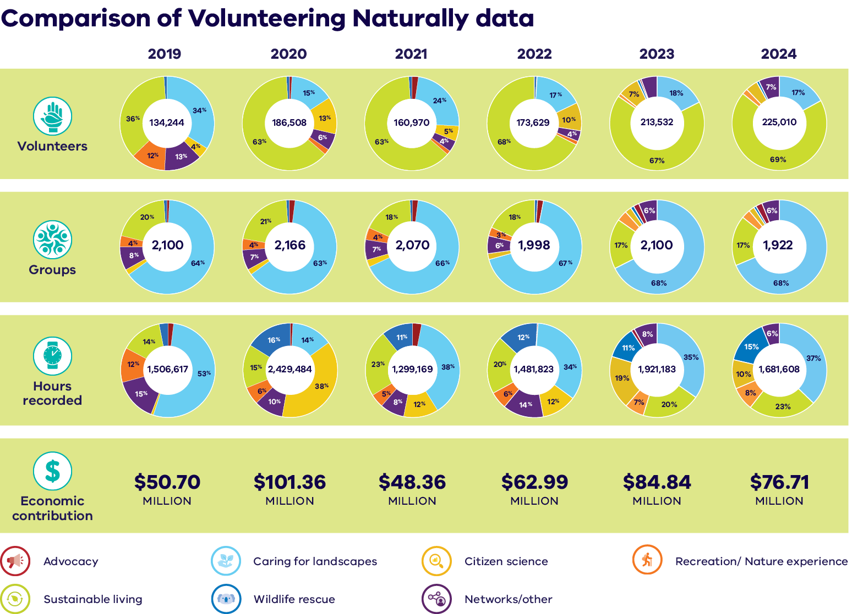

# Key observations

In 2024, the number of individuals volunteering for nature increased by five per cent on the previous year. However, there was a decrease of twelve per cent in the number of hours volunteered. This observation is consistent with what we are hearing anecdotally; people are keen to contribute and we’ve seen an increase in the numbers of individuals volunteering, however they are doing fewer hours.

## Groups

The overall number of groups and organisations involved in environmental volunteering has decreased slightly. This is consistent with the downward trend observed within the wider volunteer sector. (Note: [https://www.volunteeringaustralia.org/wp-content/uploads/  
Ongoing-trends-in-volunteering-in-Australia-November-2023.pdf](https://www.volunteeringaustralia.org/wp-content/uploads/Ongoing-trends-in-volunteering-in-Australia-November-2023.pdf))

The largest number of groups are involved in Caring for Landscapes activities. They also contribute the highest number of hours, highlighting the importance volunteers place on connecting to nature and their local places. A lot of these activities are held regularly with the same people attending each time.

## Individuals

Between 2019 and 2024, the number of people participating in different categories has fluctuated. However, Sustainable Living continues to attract volunteers with a lot involved in annual events including Clean Up Australia and National Tree Days.

## Hours

While we now have five years of environmental volunteer data, there are still no clear trends in terms of the hours contributed. This is in part due to the impacts of the COVID-19 pandemic and is consistent with the broader volunteering trend of having competing priorities for volunteer’s time.

What is clear is that Victoria has a large community of everyday people who actively care for and value our natural environment.

# Where Victorians volunteer

Volunteering for nature occurs across the whole state on both private and public land. Unsurprisingly, most volunteering occurs in the Port Phillip region, with four out of five people in Victoria living in the capital city area of Greater Melbourne. Statewide data includes programs that go across Victoria, such as WaterWatch and Birdlife, and large annual events like Clean-Up Australia Day.

Figure : Map showing where Victorians volunteer by region

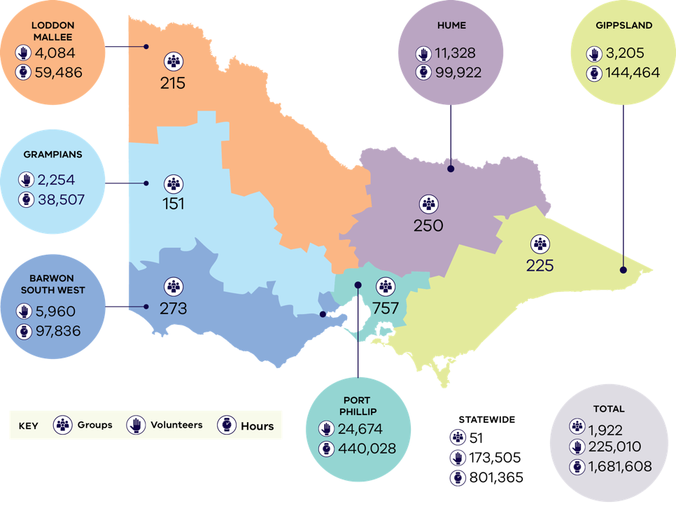

Table : Breakdown of volunteering by region

| Region | Number of  volunteer groups | Number of  volunteers | Number of hours volunteered |
| --- | --- | --- | --- |
| **Barwon South West** | 273 | 5960 | 97836 |
| **Gippsland** | 225 | 3205 | 144464 |
| **Grampians** | 151 | 2254 | 38507 |
| **Hume** | 250 | 11328 | 99922 |
| **Loddon Mallee** | 215 | 4084 | 59486 |
| **Port Phillip** | 757 | 24674 | 440028 |
| **Statewide** | 51 | 173505 | 801365 |
| **Total** | **1922** | **225010** | **1681608** |

## Thank you

Thank you to all volunteers for what you do for Victoria’s incredible natural environment. Your contributions inspire us every day.

## Our website

We have a wide range of stories, resources, training opportunities and grants available on our website that are focused on environmental volunteering.

You’ll be able to find inspiration through case studies and videos with information to support you with your activities.

Visit our website: [environment.vic.gov.au/volunteering](https://www.environment.vic.gov.au/volunteering)

## Stand up and be counted

If you’d like to check we have your environmental volunteering included in the annual snapshot so you can showcase what you do and encourage others to join you, please contact our team.

## Stay up to date

If you’re keen to keep across what’s happening in the environmental volunteering landscape subscribe to our regular e-newsletter by getting in touch with us via email.

Get in touch with our team: [environmental.volunteering@deeca.vic.gov.au](mailto:environmental.volunteering@deeca.vic.gov.au)

[environment.vic.gov.au](http://environment.vic.gov.au/)

# Publication information

## Aboriginal acknowledgement

We acknowledge and respect Victorian Traditional Owners as the original custodians of Victoria’s land and waters, their unique ability to care for Country and deep spiritual connection to it. We honour Elders past and present whose knowledge and wisdom has ensured the continuation of culture and traditional practices.

We are committed to genuinely partner, and meaningfully engage, with Victoria’s Traditional Owners and Aboriginal communities to support the protection of Country, the maintenance of spiritual and cultural practices and their broader aspirations in the 21st century and beyond.

## Dedication

This Volunteering Naturally report is dedicated to the hundreds of thousands of volunteers across Victoria who donate their time and skills to protecting our incredible natural environment. It is also dedicated to the volunteer managers and coordinators who provide critical, inspiring leadership and enable volunteer efforts to take place. Through capturing your contributions, we seek to continue spotlighting the invaluable work you’re undertaking for generations to come.

## Copyright

© The State of Victoria Department of Energy, Environment and Climate Action,   
November 2024.

## Creative Commons

This work is licensed under a Creative Commons Attribution 4.0 International licence, visit the [Creative Commons website](http://creativecommons.org/licenses/by/4.0/) (<http://creativecommons.org/licenses/by/4.0/>).

You are free to re-use the work under that licence, on the condition that you credit the State of Victoria as author. The licence does not apply to any images, photographs or branding, including the Victorian Coat of Arms, and the Victorian Government and Department logos.

**ISBN** 978-1-76136-999-5 **(pdf/online/MS word)**

## Disclaimer

This publication may be of assistance to you but the State of Victoria and its employees do not guarantee that the publication is without flaw of any kind or is wholly appropriate for your particular purposes and therefore disclaims all liability for any error, loss or other consequence which may arise from you relying on any information in this publication.

## Accessibility

To receive this document in an alternative format, phone the Customer Service Centre on 136 186, email customer.service@delwp.vic.gov.au, or contact National Relay Service on 133 677. Available at DEECA website (www.deeca.vic.gov.au).

**End of document.**