Background / preamble
The Far East Coast landscape was recognised during the 2019/20 Gippsland Biodiversity Response Planning (BRP) process as a focus area for future collaborative biodiversity action and investment.
Under the Victorian Government’s Biodiversity 2037: Protecting Victoria’s Biodiversity plan, the BRP process is a long-term area-based planning approach to biodiversity conservation in Victoria. It is designed to strengthen alignment, engagement and participation between government, Traditional Owners, non-government agencies and the community to benefit biodiversity by working together to identify, promote and tackle local biodiversity needs as part of an ongoing collective process.
In 2019/20, significant impacts from the bushfires in East Gippsland and coronavirus (COVID-19) on community, biodiversity stakeholders and agencies, and the environment, resulted in planned engagement with many local stakeholders in Gippsland about BRP being postponed to a future process. In the interim, a multi-agency working group of local staff in Gippsland came together to identify a series of potential strategic priority actions across the region, as well as 13 focus landscapes. Membership of this working group for Gippsland included staff from the Department of Environment, Land, Water and Planning (DELWP) coasts & marine policy and local forest, fire and biodiversity teams, East Gippsland and West Gippsland Catchment Management Authorities (EGCMA & WGCMA), Parks Victoria, Trust for Nature (TfN), the Bunurong Land Council Aboriginal Corporation (BLCAC) and the Gunaikurnai Land and Waters Aboriginal Corporation (GLaWAC).
As part of this process, the Gippsland BRP working group drew upon information available from the DELWP Strategic Management Prospects (SMP) tool as well as their own local knowledge to identify key biodiversity assets, threats and potential management actions across Gippsland. A subset of this information is presented in this Fact Sheet, reflecting a point in time assessment of some of the important biodiversity needs and landscapes for focus across the region.
These BRP Fact Sheets provide useful biodiversity information for the community, non-government and government organisations during project planning and development, including guidance for stakeholders interested to contribute towards some of the strategic priorities identified in these areas to date. Further information and the full list of Fact Sheets is available on the Department’s Environment website.

Landscape description
Landscape context: 242,274 ha, 94% public land, 90% native vegetation cover
This landscape includes the lowlands and coastal plains between Cabbage Tree Creek and the NSW border, between the Princes Highway and the coast east of Marlo. Comprising extensive tracts of continuous intact native vegetation, the area is a mix of National Park and State Forest, with small enclaves of freehold around Mallacoota, Genoa, Tamboon, south of Cann River, Bemm River and Cabbage Tree Creek.
Predominant vegetation types include Lowland Forest with Damp Forest in gullies and other sheltered slopes, grading to Banksia Woodland and extensive heathlands closer to the coast. Warm Temperate Rainforest (WTRF) can be found in sheltered gullies and along rivers throughout the landscape, with some large patches also within Howe Range in the east. Pockets of Littoral rainforest are present along the coast and around estuaries.
Notable biogeographic features of this landscape include Mallacoota Inlet, Wingan Inlet, Howe Range, Howe Flat, Lakes Barracoota and Wau Wauka, lower Thurra, Wingan, Genoa and Wallagaraugh Rivers, lower Bemm River, Mt Bemm, Dock Inlet, Cape Conran, Sydenham Inlet and Tamboon Inlet and the entire Betka River, Red River and Benedore River catchments.

Biodiversity highlights and important places:
One of the most species-rich landscapes in Gippsland, many species here are at the southern limit of their national distribution. This landscape is a hotspot for small to medium-sized terrestrial marsupials (e.g. bandicoots and potoroos), heathland species (e.g. diverse orchids, Ground Parrot, Eastern Bristlebird) and Lowland and Littoral rainforest communities. Significant untracked areas throughout Croajinglong National Park (UNESCO Biosphere Reserve) such as the Sandpatch Wilderness Area and Howe Range, are continuous with Nadgee Nature Reserve in NSW.
In addition to its terrestrial flora and fauna, Far East Gippsland is also home to some of the least disturbed estuaries in Victoria. Several catchments here remain completely undisturbed, with no impoundments from source to estuary (the Thurra, Bemm, Wingan and Betka catchments), and the streams east of the Bemm catchment remain trout-free. Key marine assets include Beware Reef Marine Sanctuary, Cape Howe Marine National Park, Point Hicks Marine National Park, and offshore islands The Skerries (important Australian Fur Seal colony) and Gabo and Tullaburga Islands (important seabird breeding sites).
Important vegetation communities in this landscape include:
*FFG listed | Warm Temperate Rainforest - Howe Range  Warm Temperate Rainforest - Far East Gippsland  Warm Temperate Rainforest - East Gippsland Alluvial Terraces
**EPBC listed | Littoral Rainforest and Coastal Vine Thicket  Subtropical and Temperate Coastal Saltmarsh
*Flora and Fauna Guarantee Act 1988 (Victorian)
**Environment Protection and Biodiversity Conservation Act 1999 (Federal)

Cultural importance
We would like to acknowledge the Traditional Owners and custodians of the land across this landscape. We pay our respects to Country, and to Elders past and present whose knowledge and wisdom has ensured the continuation of culture and traditional practices. We are committed to genuinely partner, and meaningfully engage, with Victoria’s Traditional Owners and Aboriginal communities to support the protection of Country, the maintenance of spiritual and cultural practices and their broader aspirations into the 21st century and beyond in the spirit of self-determination. The Gippsland BRP project team are seeking interest from traditional owners in this area to contribute towards biodiversity planning and conservation processes, including Biodiversity Response Planning.

Stakeholder and community interest
Local engagement for BRP in Gippsland in 2019/20 was postponed due to impacts from fire and coronavirus (COVID-19). If you would like to contribute local knowledge about this landscape in the future, find out more about BRP or add your name to the statewide or Gippsland BRP stakeholder lists, you can find further information on the Department’s Environment website.

Species summary
An analysis of available Habitat Distribution Models* identified 500 species with more than 5% of their Victorian range falling within the Far East Coast BRP landscape, including 91 threatened species and 17 EPBC listed species.
*Note: While version 2.0 of the SMP model utilises HDMs for ~3,200 terrestrial species in its analysis, these models currently exclude aquatic, invertebrate, marine and non-vascular plant species. These HDMs and SMP will continue to be improved upon with ongoing input from species experts and natural resource management practitioners.
Species class | Species with a high proportion of their Victorian distribution in this landscape | Other notable species identified during the BRP process
404 plants, incl. 61 threatened species (6 EPBC) | 70 species with more than 50% of their Victorian range falling within this landscape, notably:  - Green Wattle Acacia irrorata subsp. irrorata (FFG listed, vulnerable, 85% of Victorian range, restricted to East Gippsland)  - Betka Bottlebrush Callistemon kenmorrisonii (EPBC listed, Vulnerable, 83% of Victorian range, restricted to East Gippsland)  - Leafless Tongue-orchid Cryptostylis hunteriana (EPBC listed, Vulnerable, 69% of Victorian range)  - Genoa Spider-orchid Caladenia ancylosa (FFG listed, vulnerable, 69% of Victorian range, restricted to Gippsland)  - Forrester’s Bottlebrush Callistemon forresterae (EPBC listed, Vulnerable, 53% of Victorian range)  10 species with more than 90% of their Victorian range falling within the landscape, notably:  - Eastern Leatherwood Eucryphia moorei (FFG listed, vulnerable, 98% of Victorian range)  - Gum Vine Aphanopetalum resinosum (FFG listed, vulnerable, 98% of Victorian range)  - Pencil Cedar Polyscias murrayi (FFG listed, vulnerable, 97% of Victorian range)  - Tiny Spyridium Spyridium cinereum (FFG listed, vulnerable, 93% of Victorian range)  - Gippsland Banksia Banksia croajingolensis (FFG listed, endangered, 92% of Victorian range, restricted to Far East Gippsland)  - Lemon-scented Leek-orchid Prasophyllum sp. aff. odoratum K (FFG listed, vulnerable, 91% of Victorian range) | - Genoa River Correa Correa lawrenceana var. genoensis (EPBC listed, Endangered, 29% of Victorian range)  - Spiral Sun-orchid Thelymitra matthewsii (EPBC listed, Vulnerable, 18% of Victorian range)  - Thick-lip Spider-orchid Caladenia tessallata (EPBC listed, Vulnerable, 13% of Victorian range)
18 mammals, incl. 7 threatened species (6 EPBC) | 6 species with more than 10% of their Victorian range falling within this landscape, including:  - Long-nosed Potoroo (EPBC listed, Vulnerable, 23% of Victorian range)  - Long-footed Potoroo (EPBC listed, Endangered, 20% of Victorian range)  - Grey-headed Flying-fox (EPBC listed, Vulnerable, 14% of Victorian range)  - Southern Brown Bandicoot (EPBC listed, Endangered, 13% of Victorian range)  - White-footed Dunnart (10% of Victorian range)  - Long-nosed Bandicoot (10% of Victorian range) | - None raised
11 reptiles, incl. 3 threatened species (0 EPBC) | Notable species include:  - Diamond Python (FFG listed, endangered, 82% of Victorian range) | - None raised
55 birds, incl. 15 threatened species (2 EPBC) | 7 species with more than 10% of their Victorian range falling within this landscape, including:  - Eastern Bristlebird (EPBC listed, Endangered, 98% of Victorian range)  - Black Bittern (FFG listed, vulnerable, 93% of Victorian range)  - Ground Parrot (FFG listed, endangered, 41% of Victorian range)  - Glossy Black-Cockatoo (FFG listed, vulnerable, 31% of Victorian range)  - Masked Owl (FFG listed, endangered, 28% of Victorian range)  - Sooty Owl (FFG listed, vulnerable, 13% of Victorian range)  - Hooded Plover (EPBC listed, Vulnerable, 10% of Victorian range) | - Little Tern (FFG listed, vulnerable, 6% of Vic range)  - White-bellied Sea-eagle (FFG listed, vulnerable, 4% of Vic range)
12 frogs, incl. 5 threatened species (3 EPBC) | 7 species with more than 20% of their Victorian range falling within this landscape, notably:  - Keferstein’s Tree Frog (FFG listed, vulnerable, 87% of Victorian range)  - Green and Golden Bell Frog (EPBC listed, Vulnerable, 44% of Victorian range)  - Martin’s Toadlet (FFG listed, critically endangered, 30% of Victorian range)  - Large Brown Tree Frog (EPBC listed, Vulnerable, 27% of Victorian range)  - Giant Burrowing Frog (EPBC listed, Vulnerable, 20% of Victorian range) | - None raised
Other species raised by the working group (e.g. fish, invertebrates etc):
Empire Gudgeon (FFG listed, vulnerable), Mallacoota Burrowing Crayfish (FFG listed, vulnerable, restricted to this landscape), East Gippsland Spiny Crayfish (FFG listed, vulnerable, restricted to Far East Gippsland), Southern Sedge-darter Butterfly (FFG listed, vulnerable), Caddisfly Triaenodes resima (FFG listed, vulnerable)

Strategic Management Prospects
Strategic Management Prospects (SMP) models species distributions, habitat importance, landscape-scale threats, and management costs. It then compares and highlights those places with the greatest opportunities for cost-effective action state-wide. Learn more about this tool on the SMP webpage.

Which landscape-scale actions are most cost-effective in this landscape?
The maps and information below show those places and actions modelled by SMP to provide the best opportunities for cost-effective action to benefit biodiversity across the state. Coloured areas in the maps below indicate opportunities for highly cost-effective actions that provide significant benefits to biodiversity in those places. If undertaken across Victoria, these collective actions should provide the greatest potential benefit to biodiversity by focusing on undertaking landscape-scale actions in places where they will provide the greatest benefit for cost across all species.
Map a) shows actions in the top 3% cost-effectiveness areas, and Map b) shows actions in the top 10% cost-effective areas.
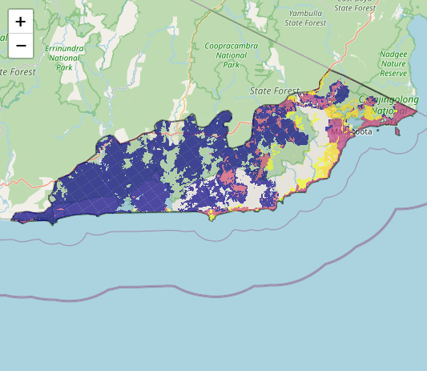
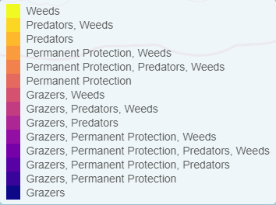
Map a) – SMP top 3% cost-effective actions
The following landscape-scale actions were ranked among the top 3% cost-effective opportunities for biodiversity action across the state by SMP:

Control deer 126,147ha
Control weeds 39,594ha
Control pigs* 31,251ha
Combined fox and cat control 19,708ha

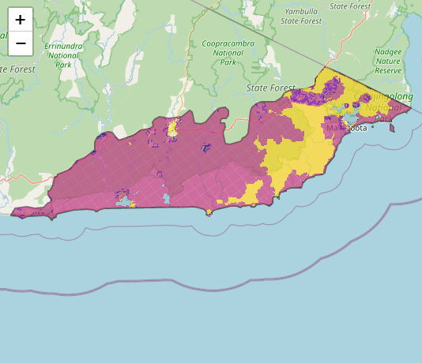
Map b) – SMP top 10% cost-effective actions
The following landscape-scale actions were ranked among the top 10% cost-effective opportunities for biodiversity action across the state by SMP:

Control weeds 236,221ha
Combined fox and cat control 228,425ha
Control deer 69,903ha
Control pigs* 31,251ha

*The Gippsland BRP working group advised feral pigs are not a current issue for this landscape, however ongoing surveillance for sign and impact would be beneficial.

The most cost-effective actions for flora & fauna according to SMP
 | Plants – Control deer, Combined fox and cat control, and Control weeds |  | Birds – Combined fox and cat control and Control deer
 | Mammals – Combined fox and cat control |  | Amphibians – Combined fox and cat control
 | Reptiles – Combined fox and cat control
For a further in depth look into SMP for this landscape please refer to NatureKit.

Additional threats raised by the working group
- Removing trout from headwaters with threatened galaxiid species
- Managing increased estuary closures and delays in openings under climate change (e.g. Sydenham Inlet)
- Controlling introduced rodents (including brown rats and house mice) on Gabo Island

Highest priority strategic actions
With consideration of the information available in SMP and local knowledge of this landscape, the Gippsland BRP working group identified the following priority actions for future collaboration and investment in this landscape:
The highest priority actions for the Far East Coast landscape include:
- Controlling transformer weeds (particularly along the coast and in littoral rainforest)
- Controlling deer (particularly in littoral rainforest)
- Integrated predator control (including the continuation and expansion of the Southern Ark fox-baiting program plus cat control around key biodiversity assets)
Other key actions highlighted by the working group include:
- Permanent protection (particularly along the Genoa River)
- Opportunities for ecological burning (particularly for the heathlands around Cape Howe)

