Nomination No. 908

FFG Threatened List Updates

**FLORA AND FAUNA GUARANTEE - SCIENTIFIC ADVISORY COMMITTEE**

# FINAL RECOMMENDATION ON UPDATES TO THE *FLORA AND FAUNA GUARANTEE ACT 1988* THREATENED LIST

[DOCID107-417469679-742](https://delwpvicgovau.sharepoint.com/sites/ecm_107/_layouts/15/DocIdRedir.aspx?ID=DOCID107-417469679-742)

**Date of receipt of nomination:** 19 June 2023

**Date of preliminary recommendation:** 1 October 2023

**Date of final recommendation decision:**  23 October 2024

**Validity**: The nomination is for valid items.

**Prescribed Information:** The prescribed information was provided.

**Name of the Nominator** is adequately provided.

**Name of the Items** is adequately provided.

**Required updates to the *Flora and Fauna Guarantee Act 1988* Threatened List**

In 2021, the *Flora and Fauna Guarantee Act 1988* (FFG Act) Threatened List was substantially updated following the completion of the Conservation Status Assessment (CSA) project undertaken by the then Department of Environment, Land, Water and Planning. The CSA project re-assessed the conservation status of plants, animals and fungi that were considered rare or threatened in Victoria. During the bulk listing of almost 2000 taxa, administrative errors resulted in the incorrect Gazettal of the Extinction Risk and/or Category of Threat for a group of taxa, and for other taxa, updated data became available after Gazettal regarding the correct Extinction Risk and/or Category of Threat (Table 1).

## Eligibility for listing on the FFG Act Threatened List

The Scientific Advisory Committee (SAC) has assessed the eligibility of the taxa in Table 1 below and are of the opinion that all are eligible for listing as each taxon satisfies at least one criterion of the set of criteria prepared and maintained under Division 2 of Part 3 of the FFG Act and stated in Schedule 1 of the FFG Regulations.

As required under the Intergovernmental Memorandum of Understanding - Agreement on a Common Assessment Method for Listing of Threatened Species (to which Victoria is a signatory), eligibility has also been assessed in accordance with the *IUCN Red List Categories and Criteria (Version 3.1)* and *Guidelines for Using the IUCN Red List Categories and Criteria (version16, 2024).*

For details of the IUCN criteria see Appendix 1.

**Decision by the Scientific Advisory Committee**

The SAC makes the final recommendation to correct errors and update the FFG Act Threatened List (Table 1). The updated Threatened List will reflect the correct status as that arising from the most current threatened species assessment report (see Appendix 2).

**Table 1:** Required corrections and updates to listed taxa on the FFG Act Threatened List.

|  |  |  |  |  |  |  |
| --- | --- | --- | --- | --- | --- | --- |
| **Taxon ID** | **Scientific Name** | **Common Name** | **Current FFG Act Extinction Risk** | **Correct FFG Act Extinction Risk** | **Current FFG Act Category of Threat** | **Correct FFG Act Category of Threat** |
| 500296 | *Astelia australiana* | Tall Astelia | Australia | No change | Critically Endangered | Endangered |
| 500432 | *Bossiaea bracteosa* | Mountain Leafless Bossiaea | Victoria | Australia | Vulnerable | Endangered |
| 500771 | *Caladenia insularis* | French Island Spider-orchid | Victoria | Australia | Endangered | No change |
| 500693 | *Celmisia sericophylla* | Silky Snow-daisy | Australia | No change | Critically Endangered | Endangered |
| 1634 | *Euastacus crassus* | Alpine Spiny Crayfish | Australia | Victoria | Endangered | No change |
| 1644 | *Euastacus yanga* | Variable Spiny Crayfish | Australia | Victoria | Endangered | No change |
| 903034 | *Galaxiella toourtkoourt* | Little Galaxias | Australia | Victoria | Endangered | No change |
| 15203 | *Geminoropa scindocataracta* | Land Snail | Victoria | Australia | Endangered | No change |
| 501488 | *Gonocarpus serpyllifolius* | Flat Raspwort | Victoria | No change | Vulnerable | Endangered |
| 501173 | *Haegiela tatei* | Small Nut-heads | Victoria | No change | Critically Endangered | Endangered |
| 507783 | *Hakea asperma* | Native Dog Hakea | Australia | No change | Endangered | Critically Endangered |
| 501581 | *Haloragis eichleri* | Eichler's Raspwort | Victoria | No change | Vulnerable | Critically Endangered |
| 503787 | *Hovea purpurea* | Tall Hovea | Victoria | No change | Vulnerable | Critically Endangered |
| 501713 | *Hydrilla verticillata* | Hydrilla | Victoria | No change | Vulnerable | Critically Endangered |
| 501942 | *Leiocarpa gatesii* | Wrinkled Buttons | Australia | No change | Critically Endangered | Endangered |
| 501909 | *Lepidium pseudopapillosum* | Erect Peppercress | Victoria | No change | Critically Endangered | Endangered |
| 503863 | *Maireana georgei* | Slit-wing Bluebush | Victoria | No change | Critically Endangered | Endangered |
| 502232 | *Muellerina celastroides* | Coast Mistletoe | Victoria | No change | Critically Endangered | Endangered |
| 504846 | *Prostanthera lasianthos* var*. subcoriacea* | Grampians Christmas-bush | Victoria | Australia | Vulnerable | No change |
| 504727 | *Pterostylis* X *aenigma* | Enigmatic Greenhood | Victoria | Australia | Critically Endangered | No change |
| 75236 | *Temognatha sanguinipennis* | Jewel Beetle | Victoria | No change | Endangered | Vulnerable |
| 15050 | *Victaphanta compacta* | Otway Black Snail | Victoria | Australia | Endangered | No change |

**Documentation**

The published information provided to and sourced by the SAC has been assessed. To the best of their knowledge, the SAC believes that the data presented are not the subject of scientific dispute and the inferences drawn are reasonable and well-supported.

**Advertisement for public comment**

In accordance with the requirements of Section 16D of the FFG Act, the preliminary recommendation was advertised for a period of at least 30 days.

The preliminary recommendation was advertised in:

Victorian Government Gazette on 16 August 2024

DEECA website

Public submissions closed on 16 September 2024.

**Additional information considered by the Scientific Advisory Committee**

Following publication of the preliminary recommendation, the SAC did not receive any public submissions. In formulating its final recommendation, the SAC was not aware of any evidence to warrant a change to the preliminary recommendation that the required updates to the Threatened List be made.

**Final Recommendation of the Scientific Advisory Committee**

The Scientific Advisory Committee makes a final recommendation that the taxa in Table 1 be updated on the Threatened List in accordance with Section 16D of the *Flora and Fauna Guarantee Act 1988*.

**Endorsement by the Convenor of the Scientific Advisory Committee** **Date**

signed by

____________________________

**Dr. Michelle T. Casanova 24 October 2024**

**Convenor**

**Appendix 1:** IUCN Red List Categories and Criteria

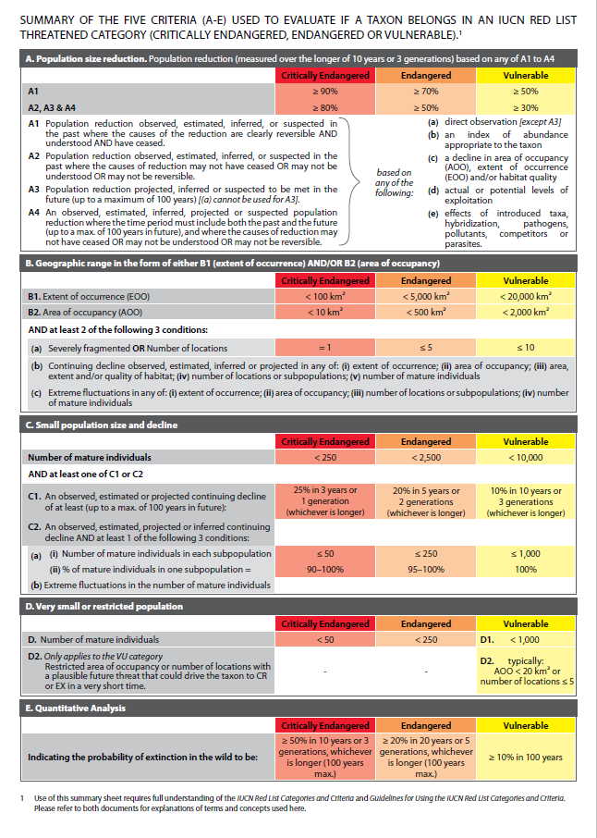

**Appendix 2: Threatened Species Assessment Reports.**

|  |  |  |  |
| --- | --- | --- | --- |
| **Taxon ID** | **Scientific Name** | **Common Name** | **Link to Threatened Species Assessment Report.** |
| 500296 | *Astelia australiana* | Tall Astelia | PDF: <https://www.environment.vic.gov.au/conserving-threatened-species/threatened-list?a=675424>  Microsoft Word (accessible): <https://www.environment.vic.gov.au/conserving-threatened-species/threatened-list?a=675423> |
| 500432 | *Bossiaea bracteosa* | Mountain Leafless Bossiaea | PDF:  <https://www.environment.vic.gov.au/conserving-threatened-species/threatened-list?a=675426>  Microsoft Word (accessible):  <https://www.environment.vic.gov.au/conserving-threatened-species/threatened-list?a=675425> |
| 500771 | *Caladenia insularis* | French Island Spider-orchid | PDF:  <https://www.environment.vic.gov.au/conserving-threatened-species/threatened-list?a=675428>  Microsoft Word (accessible):  <https://www.environment.vic.gov.au/conserving-threatened-species/threatened-list?a=675427> |
| 500693 | *Celmisia sericophylla* | Silky Snow-daisy | PDF:  <https://www.environment.vic.gov.au/conserving-threatened-species/threatened-list?a=675386>  Microsoft Word (accessible):  <https://www.environment.vic.gov.au/conserving-threatened-species/threatened-list?a=675385> |
| 1634 | *Euastacus crassus* | Alpine Spiny Crayfish | PDF:  <https://www.environment.vic.gov.au/conserving-threatened-species/threatened-list?a=675388>  Microsoft Word (accessible):  <https://www.environment.vic.gov.au/conserving-threatened-species/threatened-list?a=675387> |
| 1644 | *Euastacus yanga* | Variable Spiny Crayfish | PDF:  <https://www.environment.vic.gov.au/conserving-threatened-species/threatened-list?a=675390>  Microsoft Word (accessible):  <https://www.environment.vic.gov.au/conserving-threatened-species/threatened-list?a=675389> |
| 903034 | *Galaxiella toourtkoourt* | Little Galaxias | PDF:  <https://www.environment.vic.gov.au/conserving-threatened-species/threatened-list?a=675392>  Microsoft Word (accessible):  <https://www.environment.vic.gov.au/conserving-threatened-species/threatened-list?a=675391> |
| 15203 | *Geminoropa scindocataracta* | Land Snail | PDF:  <https://www.environment.vic.gov.au/conserving-threatened-species/threatened-list?a=675394>  Microsoft Word (accessible):  <https://www.environment.vic.gov.au/conserving-threatened-species/threatened-list?a=675393> |
| 501488 | *Gonocarpus serpyllifolius* | Flat Raspwort | PDF:  <https://www.environment.vic.gov.au/conserving-threatened-species/threatened-list?a=675396>  Microsoft Word (accessible):  <https://www.environment.vic.gov.au/conserving-threatened-species/threatened-list?a=675395> |
| 501173 | *Haegiela tatei* | Small Nut-heads | PDF:  <https://www.environment.vic.gov.au/conserving-threatened-species/threatened-list?a=675398>  Microsoft Word (accessible):  <https://www.environment.vic.gov.au/conserving-threatened-species/threatened-list?a=675397> |
| 507783 | *Hakea asperma* | Native Dog Hakea | PDF:  <https://www.environment.vic.gov.au/conserving-threatened-species/threatened-list?a=675400>  Microsoft Word (accessible): <https://www.environment.vic.gov.au/conserving-threatened-species/threatened-list?a=675399> |
| 501581 | *Haloragis eichleri* | Eichler's Raspwort | PDF:  <https://www.environment.vic.gov.au/conserving-threatened-species/threatened-list?a=675402>  Microsoft Word (accessible):  <https://www.environment.vic.gov.au/conserving-threatened-species/threatened-list?a=675401> |
| 503787 | *Hovea purpurea* | Tall Hovea | PDF:  <https://www.environment.vic.gov.au/conserving-threatened-species/threatened-list?a=675404>  Microsoft Word (accessible):  <https://www.environment.vic.gov.au/conserving-threatened-species/threatened-list?a=675403> |
| 501713 | *Hydrilla verticillata* | Hydrilla | PDF:  <https://www.environment.vic.gov.au/conserving-threatened-species/threatened-list?a=675406>  Microsoft Word (accessible):  <https://www.environment.vic.gov.au/conserving-threatened-species/threatened-list?a=675405> |
| 501942 | *Leiocarpa gatesii* | Wrinkled Buttons | PDF:  <https://www.environment.vic.gov.au/conserving-threatened-species/threatened-list?a=675408>  Microsoft Word (accessible):  <https://www.environment.vic.gov.au/conserving-threatened-species/threatened-list?a=675407> |
| 501909 | *Lepidium pseudopapillosum* | Erect Peppercress | PDF:  <https://www.environment.vic.gov.au/conserving-threatened-species/threatened-list?a=675410>  Microsoft Word (accessible):  <https://www.environment.vic.gov.au/conserving-threatened-species/threatened-list?a=675409> |
| 503863 | *Maireana georgei* | Slit-wing Bluebush | PDF:  <https://www.environment.vic.gov.au/conserving-threatened-species/threatened-list?a=675412>  Microsoft Word (accessible):  <https://www.environment.vic.gov.au/conserving-threatened-species/threatened-list?a=675411> |
| 502232 | *Muellerina celastroides* | Coast Mistletoe | PDF:  <https://www.environment.vic.gov.au/conserving-threatened-species/threatened-list?a=675414>  Microsoft Word (accessible):  <https://www.environment.vic.gov.au/conserving-threatened-species/threatened-list?a=675413> |
| 504846 | *Prostanthera lasianthos* var*. subcoriacea* | Grampians Christmas-bush | PDF:  <https://www.environment.vic.gov.au/conserving-threatened-species/threatened-list?a=675416>  Microsoft Word (accessible):  <https://www.environment.vic.gov.au/conserving-threatened-species/threatened-list?a=675415> |
| 504727 | *Pterostylis* X *aenigma* | Enigmatic Greenhood | PDF:  <https://www.environment.vic.gov.au/conserving-threatened-species/threatened-list?a=675418>  Microsoft Word (accessible):  <https://www.environment.vic.gov.au/conserving-threatened-species/threatened-list?a=675417> |
| 75236 | *Temognatha sanguinipennis* | Jewel Beetle | PDF:  <https://www.environment.vic.gov.au/conserving-threatened-species/threatened-list?a=675420>  Microsoft Word (accessible):  <https://www.environment.vic.gov.au/conserving-threatened-species/threatened-list?a=675419> |
| 15050 | *Victaphanta compacta* | Otway Black Snail | PDF:  <https://www.environment.vic.gov.au/conserving-threatened-species/threatened-list?a=675422>  Microsoft Word (accessible):  <https://www.environment.vic.gov.au/conserving-threatened-species/threatened-list?a=675421> |