**Weeds and Pests on Public Land** Program Report 2023-2024

*Accessible version*



## Weeds and Pests on Public Land 2023-24

2

* The Weeds and Pests on Public Land (WPPL) Program aims to protect biodiversity across the state of Victoria through targeting threats to ecosystems such as weeds, rabbits, and foxes. These invasive species threaten native plant, animal, and fungi species through reducing their populations, damaging their habitats, or by competing directly with them for resources.
* The WPPL Program invests over $3 million each year, with an additional $1 million provided each year by Parks Victoria.
* There are 8 flagship projects within WPPL: the 3 x Arks undertaking fox control, the 3 x Edens undertaking weed control, the Mallee Bounceback which targets rabbits, and the Weeds at the Early Stage of Invasion project which builds the capability of land managers to respond to early invader weeds.
* The WPPL Program could not operate without its excellent network of collaborative partnerships, which in 2023-24 involved 61 partners across several iconic national and state parks such as the Grampians, Murray Sunset, and Croajingolong National Parks.

OFFICIAL

OFFICIAL

3

**WPPL Program Achievements in 2023-24**

694,615

Total hectares of predator control

648,755 Ha in priority locations

39,829

Total hectares of herbivore control

36,100 Ha in priority locations

16,482

Total hectares of weed control

4,321 Ha in priority

locations

$1,524,946

of co-investment provided by project partners

16.85

Staff directly employed

12

Traditional Owner groups engaged or involved

61

Delivery partners and key stakeholders

4,349

Volunteer hours

22

Community engagement events delivered by projects

4

OFFICIAL

## What threatened species are benefiting?

**Metallic Sun-orchid** (*Thelymitra epipactoides)*

Monitoring is carried out annually each spring for this endangered species in the Port Campbell area of the Otway Eden weed control project.

**Semi Arid Woodlands**

e.g. Belah (*Casuarina pauper*), Buloke (*Allocasuarina luehmannii*), Slender Cypress Pine (*Callitris gracilis*), and Sugarwood (*Myoporum platycarpum*)

Southern Ark fox control in combination with 3 consecutive La Niña years has resulted in a strong population response from this species in East Gippsland

**Long-footed Potoroo** (*Potorous longipes*)

In the Mallee Bounceback area, some of these species are slowly showing signs of recovery, with monitoring between 2012- 2024 detecting slight improvements in vegetation condition.

## 5

## Partnering and collaborating with Traditional Owners

**Southern Ark**

Partners with 4 Traditional Custodian Groups: Moogji Aboriginal Council, Gunaikurnai Land and Waters Aboriginal Corporation, Gippsland and East Gippsland Aboriginal Cooperative Ltd, and the Bidwell First Nations Clans Aboriginal Corporation.

Moogji is engaged to deliver fox baiting at 116 sites on public land in the East Gippsland project area to build capability and experience.

**Glenelg Ark**

Work closely with Gunditj Mirring Traditional Owners Aboriginal Corporation to provide technical expertise and equipment around

**Otway Eden**

Wadawurrung Traditional Owners Aboriginal Corporation were engaged in the Surf Coast area to deliver weed control works.

Otway Eden also delivered Phosphite spray training to Wadawurrung for Phytophthora cinnamomi vulnerable vegetation.

# 6 Grampians Ark

OFFICIAL

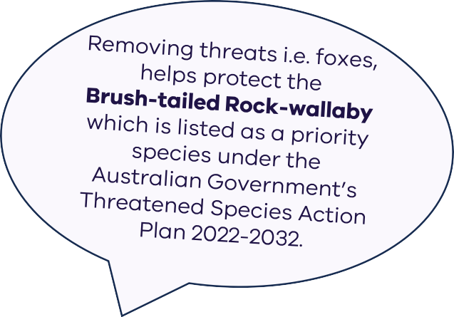**Landscape-scale fox control to protect native mammals in the Grampians National Park**

5 days of training

for 2 x Otways Parks Victoria

staff on soft jaw trapping

3,952 volunteer hours

163,478 Ha of fox control

40,677 Ha of cat control

4 presentations

to Castlemaine Field Naturalists Club, Friends of Grampians Gariwerd, Great Gariwerd Bird Survey, and Nature Stewards

From Deakin University’s small

mammal surveys in 2023:

143 records of Yellow-footed Antechinus

148 records of Heath Mouse

14 records of Southern Brown Bandicoot

3 records of Eastern Pygmy Possum

3,806 baits deployed for fox control at

1,064 bait stations with

14% of baits taken

# 7 Glenelg Ark

OFFICIAL

**Landscape-scale fox control to protect the native biodiversity of Victoria’s far south-west**

73,063 Ha of fox control

Project staff ran a species ID session using the 2023 monitoring photos for field staff at the Heywood work centre

3 community events/school visits

Project staff presented to year 9 students of the Glenelg area for a career exhibition, highlighting endangered species in the area

14,170 baits deployed

for fox control at

545 bait stations with

9% of baits taken

# 8 Southern Ark

OFFICIAL

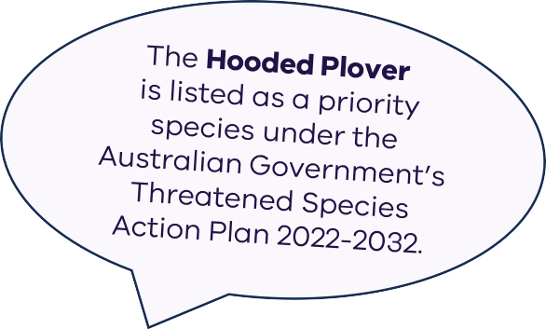**Landscape-scale fox control to protect the native biodiversity across eastern Victoria**

458,074 Ha of fox control

130 camera-traps deployed to continuously monitor invasive species (and also native wildlife) across 13 transects across the Southern Ark footprint

4 school visits and presentations

4 Viva Engage/Yammer posts

1 Gippsland newsletter story

1 media release in Snowy River Mail

1 video on native birds in Southern Ark

22,216 baits deployed

for fox control at

3,047 bait stations with

37% of baits taken

# 9 Southern Ark

**Landscape-scale fox control to protect the native biodiversity across eastern Victoria**

**Case Study: Working with the Gunaikurnai Land****and Waters Aboriginal Corporation**

Southern Ark partners with 4 Traditional Owner groups in the East Gippsland area through the delivery of its fox control program.

In June 2024, Southern Ark held a 2-day training event at Mullungdung and Won Wron State Forests with staff from the Gunaikurnai Land and Waters Aboriginal Corporation (GLaWAC) Latrobe Natural Resource Management team.

The aim of the collaboration was to share advice gained from 20+ years of running the Southern Ark project and to discuss the fox control program that GLaWAC will be implementing to reduce the threat of this invasive species on Country.

OFFICIAL

# Central Highlands Eden

OFFICIAL

10

**Reducing the impact of high threat weeds to protect native biodiversity of Victoria’s Central Highlands**

10 partners involved including Councils, Alpine Resorts, CMA’s and Water Authorities.

4,522 Ha of weed control

24 eradication target species 18 containment target species 107 asset protection species

Central Highlands Eden coordinated an “Edens” and WESI annual catch up, with the team also presenting at this workshop.

Shared challenges and methods for weed control were shared with the group.

# Central Highlands Eden

11

**Reducing the impact of high threat weeds to protect native biodiversity of Victoria’s Central Highlands**

**Case Study: Catching the Chocolate Vine**

Chocolate Vine (*Akebia quinata*) is an invasive weed species that spreadsby forming dense mats, suffocating nearby vegetation.

While not yet mapped in the Central Highlands Eden (CHE) project area, its presence is increasing in the Dandenong Ranges, east of Melbourne. It’s important to act early to catch these weeds before they spread.

In October 2023, CHE project staff, along with Kate Blood (DEECA) and Sander Groeneveld (Diverse Bush Management), inspected several infestations in the Dandenong Ranges.

Specimens collected were submitted to the National Herbarium of Victoria.

Chocolate Vine has five stalked leaflets and flowers in spring with a sweet, chocolate-like fragrance. It produces separate male (rosy purple) and female (chocolate-purple) flowers, followed by elongated pods containing seeds that may be bird-dispersed.

Early intervention is key to managing Chocolate Vine. If sightings occur in the CHE project area or elsewhere, please notify project staff or the relevant land manager.

OFFICIAL

# 12 Glenelg Eden

OFFICIAL

**Reducing the impact of high threat weeds to protect the native biodiversity of Victoria’s far south-west**

53 eradication target species 18 containment target species 7 asset protection species

$1,228,100

worth of complementary projects on integrated pest control (controlling weeds, pigs, foxes) nearby the project area

288 sites for monitoring – approx. 25 of these are new

in 2023-24

3,996 Ha of weed control

Media release on “Tackling Invasive Weeds in the Far South West” developed in 2024

13 **Otway Eden**

OFFICIAL

373 volunteer hours

**Reducing the impact of environmental weeds to restore the biodiversity of the Otway Ranges National Park**

17 delivery partners

7,963 Ha of weed control

25 eradication target species 33 containment target species 41 asset protection species

Monitoring of the threatened Metallic Sun Orchid is carried out annually each Spring in the Port Campbell asset area.

Gerangamete Landcare Group - weed identification and control training day at Forrest.

Hosted by Otway Eden Project Officer Gary Summers (focus on Asparagus Fern and Sweet Pittosporum).

14 **Otway Eden**

**Reducing the impact of environmental weeds to restore the biodiversity of the Otway Ranges National Park**

**Case Study: Sweet Pittosporum Control**

In December 2023, Parks Victoria and VicRoads worked together to address a Sweet Pittosporum (*Pittosporum undulatum*) infestation near and in the Port Campbell National Park.

Sweet Pittosporum is non-native to western Victoria, with its native range being coastal areas of eastern Australia.

The aim was to manage this weed species and to ensure a good return on investment for both organisations.

Both parties worked together to create a clear project plan with defined roles and lines of communication for the removal of the infestation.

Otway Eden mechanically mulched 2 hectares in the road reserve and applied a cut-and-paste treatment to another 2 hectares.

In the Port Campbell National Park, 50 hectares were assessed and treated.

Work was planned to avoid wildlife breeding periods and followed strict hygiene protocols, reducing the risk of spreading pathogens like *Phytophthora cinnamomi*.

This successful collaboration not only protected biodiversity but also established a

model for future cross-agency initiatives.

OFFICIAL

# 15 Weeds at the Early Stage of Invasion

OFFICIAL

**Supporting Victorian land managers to manage environmental weeds threatening our native biodiversity**

Social media engagement

9 social media accounts across

5 different platforms 2,805 followers across all platforms

4 community events/ school visits

2 WESI training events delivered

2 newsletters published

76 weed management cases

4 field trips

for early invader weed identification and management discussions at Horsham/Wimmera River, Goroke State Forest, Clear Lake Reserve, and Wilsons Promontory

# 16 Mallee Bounceback

OFFICIAL

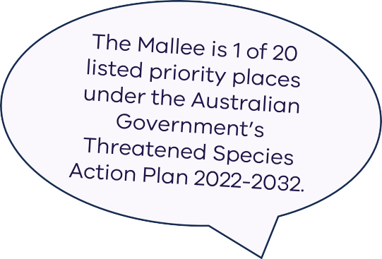**Protecting and restoring the biodiversity of semi-arid woodlands in north-western Victoria**

Teams within Parks Victoria (PV) treated approx. 200 sites at registered and highly sensitive cultural sites adjacent to and within the Mallee Bounceback project area

2 Aboriginal staff members were employed into the North-west District PV Team and will assist with the rabbit control program

39,829 Ha of rabbit control

3,314 rabbit warrens fumigated

417 rabbit warrens ripped

Biodiversity monitoring at 60 sites

These sites were monitored for Semi Arid Woodlands vegetation condition in the Murray Sunset National Park

182 sites were monitored for Rapid Rabbit Assessments

# 17 Mallee Bounceback

**Protecting and restoring the biodiversity of semi-arid woodlands in north-western Victoria**

**Case Study: Ongoing Restoration at Raak Plain**

The Raak Plain Reference Area (RPRA) within the Murray Sunset National Park is crucial for biodiversity but faces serious threats from invasive species, particularly rabbits.

The RPRA was established in 1989 and is adjacent to high-value ecological zones in the nearby national park.

A longstanding rabbit control program, spanning over three decades, aims to restore Semi Arid Woodlands by managing rabbit populations strategically across the park.

Additionally, work is being undertaken to carry out comprehensive mapping in the area, aiming to guide the control of invasive weeds and 1,036 recently identified rabbit warrens.

These actions are essential to prevent the RPRA from becoming overrun by

invasive species, which could undermine decades of conservation work.

By continuing to manage rabbit populations effectively, natural resource managers in the Mallee can protect and preserve the biodiversity of Raak Plain for future generations.

OFFICIAL

**Weeds and Pests on Public Land** Program Report 2023-2024

*Accessible version*



OFFICIAL