Peri-urban Weed Management Partnerships Program (PWMP)

2025-27 Guidelines



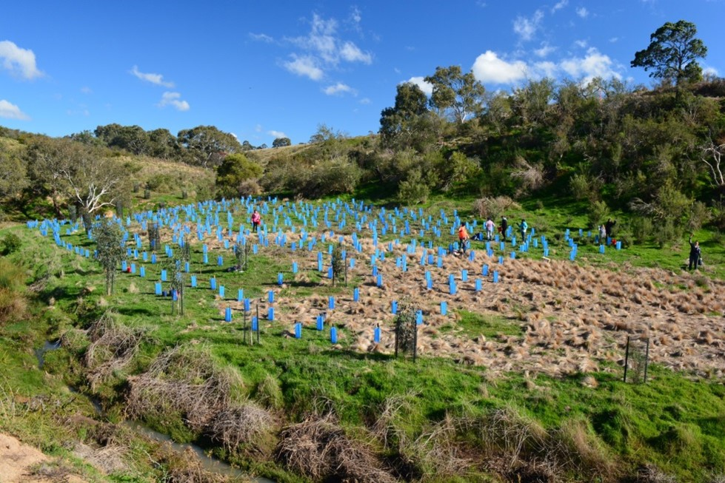

[deeca.vic.gov.au](https://delwpvicgovau.sharepoint.com/Users/fionadurante/Downloads/deeca.vic.gov.au)



We acknowledge and respect Victorian Traditional Owners as the original custodians of Victoria’s land and waters, their unique ability to care for Country and deep spiritual connection to it.

We honour Elders past and present whose knowledge and wisdom   
has ensured the continuation of culture and traditional practices.

DEECA is committed to genuinely partnering with Victorian Traditional Owners and Victoria’s Aboriginal community to progress their aspirations.

© The State of Victoria Department of Energy, Environment and Climate Action 2024.

Creative Commons

This work is licensed under a Creative Commons Attribution 4.0 International licence, visit the [Creative Commons website](http://creativecommons.org/licenses/by/4.0/) (<http://creativecommons.org/licenses/by/4.0/>).

You are free to re-use the work under that licence, on the condition that you credit the State of Victoria as author. The licence does not apply to any images, photographs or branding, including the Victorian Coat of Arms, and the Victorian Government and Department logos.

Disclaimer

This publication may be of assistance to you but the State of Victoria and its employees do not guarantee that the publication is without flaw of any kind or is wholly appropriate for your particular purposes and therefore disclaims all liability for any error, loss or other consequence which may arise from you relying on any information in this publication.

Accessibility

To receive this document in an alternative format, phone the Customer Service Centre on 136 186, email [customer.service@deeca.vic.gov.au](mailto:customer.service@deeca.vic.gov.au), or contact National Relay Service on 133 677. Available at [DEECA website](http://www.deeca.vic.gov.au/) (www.deeca.vic.gov.au).

Contents

1 What is the PWMP program? 2

1.1 Objectives 2

2 Who can apply? 8

3 Who cannot apply? 8

4 What might be funded? 9

5 What will not be funded? 10

6 What are the funding details? 10

6.1 Available Funding 10

6.2 Matched funding criteria 10

6.3 Traditional Owner Partnerships and Engagement 10

7 What are the assessment criteria? 11

8 What are the funding conditions? 12

8.1 Funding agreements 12

8.2 Reporting requirements 12

8.3 Duty of Care Requirements 13

8.4 Legislative and regulatory requirements 13

8.5 Tax implications 13

8.6 Acknowledging the Victorian Government for their support 14

8.7 Payments 14

8.8 Monitoring 14

8.9 Privacy 14

9 What is the application process? 15

9.1 Information and Q&A session 15

10 What is the notification process? 15

11 Key dates 15

12 Checklist 16

# **What is the PWMP program?**

The Peri-urban Weed Management Partnerships (PWMP) program is a 2-year competitive grants program providing funding from 2025-27 to protect native plant and animal species from invasive weeds in Melbourne's peri-urban areas (**Figure 1**).

The PWMP program is designed to:

* Protect key environmental values on public land in Melbourne’s peri-urban areas.
* Operates as a matched funding partnership between the State Government and project partners to leverage local leadership in the management of high-risk weeds within peri-urban areas.
* Operate as a partnership model, with collaborative decision-making between all weed management stakeholders—including Victorian Government agencies, Traditional Owners, community groups—to agree on investment priorities, management actions, roles and responsibilities.
* Align with the Victorian Government’s biodiversity plan Protecting Victoria’s Environment –Biodiversity 2037[1] and objectives to:
* increase the number of Victorians acting to protect nature in the project areas;
* establish effective environmental partnerships within the program footprint; and
* target weed control in priority locations.

These measurable objectives are directly identified in *Biodiversity 2037*:

* To encourage more Victorians to value nature (this includes increasing the number of Victorians acting to protect nature e.g. volunteering); and
* To ensure that Victoria’s natural environment is healthy (this means ensuring Victoria has flourishing plant and animal populations, improved habitats and functioning resilient ecosystems).

## Objectives

The 2025-27 Peri-urban Weed Management Partnership program is a competitive 2-year grant program which will be delivered through a single funding round. To be funded, projects need to meet the objectives and eligibility criteria. The program will focus on collaboration, capacity building and community engagement as well as on-ground weed management. Projects will be required to collect data and report on target outcomes and indicators. To be funded, projects need to meet the following objectives:

**Objective 1: Increase the number of Victorians acting to protect nature in the project areas**

This objective is in place to encourage more Victorians to value nature and increase the number of Victorians acting to protect nature. This objective will be measured by the following target:

Table 1. Objective 1 Description

|  |  |  |
| --- | --- | --- |
| **Outcome** | **Indicator** | **Unit of Measure** |
| Victorians value nature –  *“Increased opportunities to connect with nature and act to protect the natural environment”* | Number of community members participating in conservation action/improved land management. | Number of community members participating in program  Number of volunteer hours  Number of community events delivered through the program |

Community groups, such as Landcare, Friends of Groups, and local environmental organisations, should be involved throughout the project, from planning through to implementation. Engagement with community groups can foster a sense of ownership over the project and promote long-term sustainability.

Key principles:

* Collaboration with community groups for on-ground activities.
* Encouraging community participation in project planning and execution.
* Education and capacity-building initiatives to empower community members in weed management.

**Objective 2: Establish effective environmental partnerships within the program footprint**

This objective is in place to encourage a collaborative management approach. Projects must engage and empower all key stakeholders, including community and Traditional Owners, in the approach, purpose and delivery of the program. This objective will be measured by the following target:

Table 2. Objective 2 Description

|  |  |  |
| --- | --- | --- |
| **Outcome** | **Indicator** | **Unit of Measure** |
| Victorians value nature -  “*Increased partnerships and collaborations*” | Number of partnerships formed to deliver projects. | Number of community groups, organisations and agencies participating in program. |

Project leads must work closely with all environmental stakeholders to maximise project effectiveness. It is expected that the land manager where on ground works are being delivered are a project partner.

Key principles:

* All public land managers, Traditional Owners and local environmental community groups are engaged within the project footprint (and partnering where desired)
* Projects that involve multiple partners (including across multiple LGAs) are strongly encouraged.
* Partnerships should focus on aligning regional strategies, resource sharing, and maximising the impact of weed control efforts.
* Projects encouraged to consider partnerships with other environmental programs (e.g. Deer Control Program; Melbourne Strategic Assessment Program etc.) as part of a holistic and coordinated landscape management approach.

Where Traditional Owners are not leading projects, applications should include funding to support Traditional Owner decision making and participation in project delivery.

Traditional Owners and Aboriginal community interested groups should be supportive of the activity and have opportunities to deliver or be involved in delivery of activities. The extent and nature of involvement must be directed by Traditional Owner interests and aspirations.

Increased focus will be placed on building and supporting partnerships with Traditional Owners, for a coordinated, cross-tenure approach to weed and pest management, including identifying:

* Increased opportunities for Aboriginal environmental business and employment to support participation in environment management to achieve project deliverables
* Capacity Building with Traditional Owners on country for protection of Cultural Values
* Create more opportunities for Traditional Owners to build programs that can assist with working on country
* Traditional Owner groups to be invited to sit on the Working Group
* Opportunities to encourage inclusion of cultural knowledge and values into planning and delivery.

Project proposals should be developed in partnership with key stakeholders to ensure their aspirations, targets, budget and co-contributions are captured upfront. See section 3.4 for more details.

**Objective 3: Target weed control to priority locations**

This objective is in place to ensure that Victoria’s natural environment is healthy and has flourishing plant and animal populations, improved habitats, and functioning resilient ecosystems. This objective will be measured by the following targets:

Table 3. Objective 3 Description

|  |  |  |
| --- | --- | --- |
| **Outcome** | **Indicator** | **Unit of Measure** |
| Victoria’s natural environment is healthy-  “Increased *actions to manage the threat of weeds to conserve, protect, and enhance ecosystems, species, flora and fauna and their habitats”* | * Total area of weed control * Total area of weed control in priority locations | Hectares (ha) |

To maximise biodiversity outcomes, projects must demonstrate clear benefits to biodiversity and threatened species, supported by relevant tools, data, and evidence. The assessment of biodiversity benefit should consider Strategic Management Prospects (SMP)[2] as well as additional justifications for ecological importance beyond SMP. Benefit-Cost layers from SMP should guide decisions, ensuring the highest value investment, but is not the sole determining factor for eligibility. Key approaches to selecting project areas include:

**Strategic Management Prospects (SMP)**

* SMP provides a valuable tool for identifying areas where weed management actions offer the greatest benefits to biodiversity, informed by species distributions, threat models, action effectiveness, and cost-benefit ratios. It helps identify priority areas where management actions can protect rare and threatened species.
* Combined with local knowledge, SMP can be used to help projects identify areas where weed management can provide the highest benefits and cost-effective benefits to biodiversity. This information can be used to map project management zones and prioritise investment.
* Identify and prioritise project areas within the Top 15% Benefit-Cost weed control locations (**Figure 2**), or if not feasible, within the Top 15% Benefit weed control locations (**Figure 3**) as the next best option. SMP layers can be viewed from [NatureKit (environment.vic.gov.au)](https://www.environment.vic.gov.au/biodiversity/naturekit).

**High-Priority Species and Habitats**

* Projects that focus on high-priority species or critical habitats, including those not covered by SMP but documented in Threatened Species Action Statements, Recovery Plans, or regional biodiversity strategies (e.g. Port Phillip and Westernport Region NRM Action Plan[3]), will also be eligible.
* Justifications for such projects should include detailed ecological data, expert reports, or other credible sources to demonstrate the significance of the species or habitat targeted.

**Ecological Connectivity and Landscape-Scale Impacts**

* Landscape-scale projects that aim to improve ecological connectivity and protect biodiversity across multiple ecosystems will be highly regarded. These projects should focus on enhancing natural corridors, linking fragmented habitats, or contributing to larger-scale pest and weed management across tenure boundaries.
* Projects that address threats to ecosystem services or focus on critical biodiversity hotspots—even outside SMP priority areas—will also be eligible, provided they demonstrate strong evidence of ecological importance.

**Species or Habitats of Local or Cultural Importance:**

* Projects targeting species or habitats of particular local significance, or those identified as having high cultural value for Traditional Owners, will be considered.
* Justifications must provide local knowledge, cultural heritage assessments, or consultations with Traditional Owners to validate the project's importance.

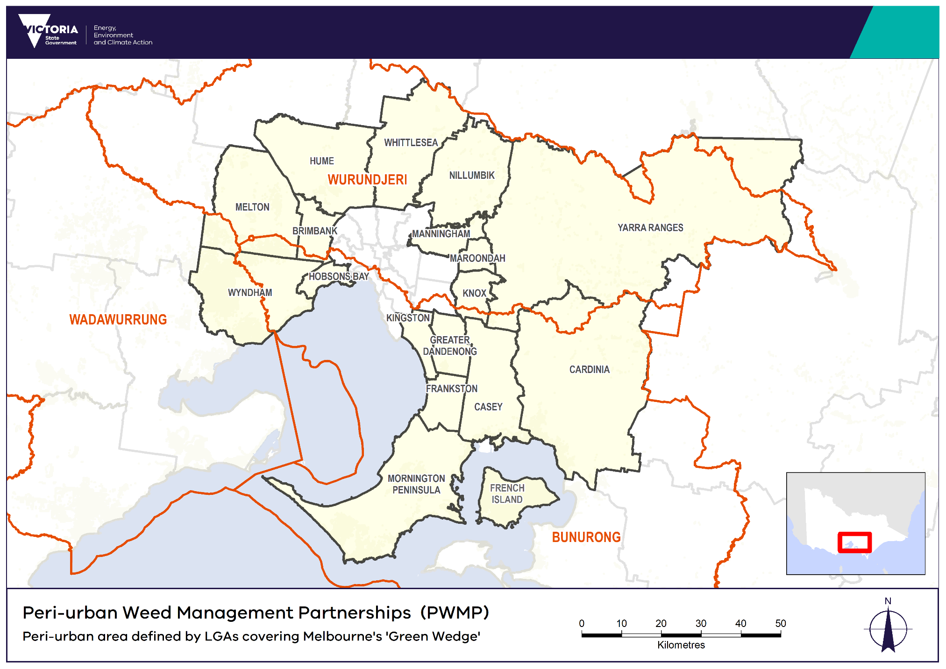

Figure 1. Located across Bunurong, Wurundjeri and Wadawurrung Country, the peri-urban area is defined as the 17 local government areas (LGA’s) that intersect

with one of Melbourne’s Green Wedges and French Island.

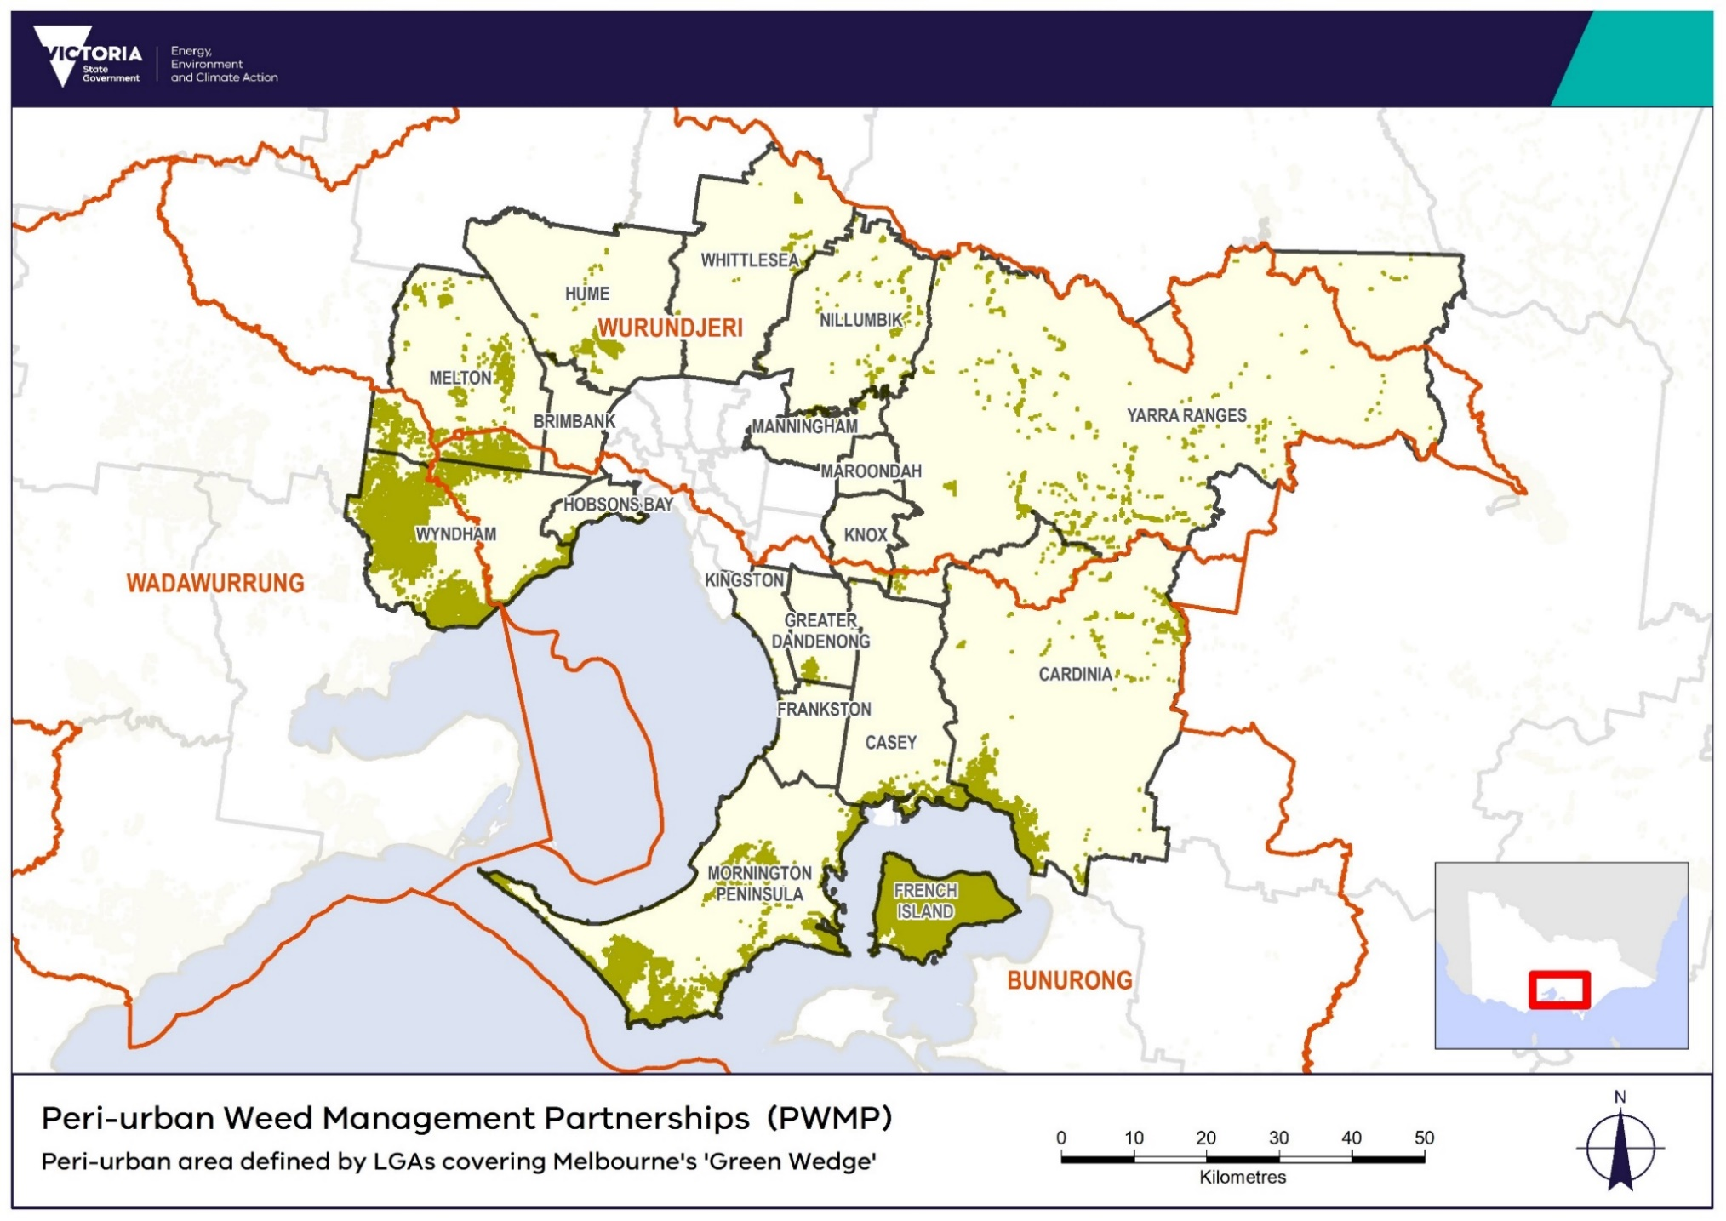

**Figure 2.** SMPTop 15% Benefit-Cost weed control locations (priority areas) within eligible PWMP footprint.

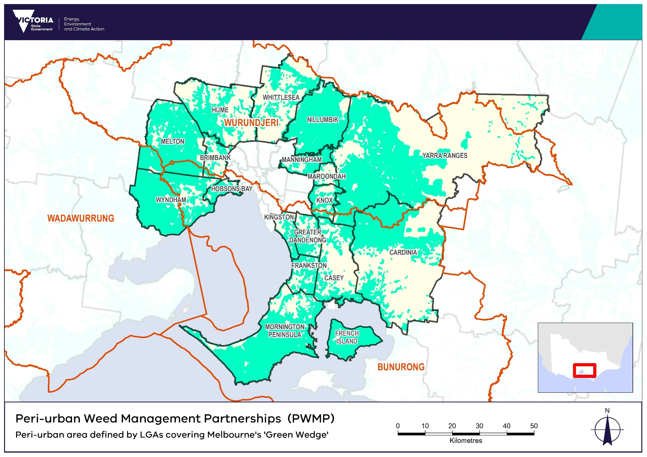

**Figure 3.** SMPTop 15%Benefit weed control locations within eligible PWMP footprint.

# **Who can apply?**

PWMP 2025-27 funding is targeted towards weed management projects that are collaboratively developed and implemented on public land across the defined Peri-urban Area (**Figure 1**). Project leads eligible to apply for funding include three Registered Aboriginal Parties, Parks Victoria and 17 local councils:

* Bunurong Land Council Aboriginal Corporation
* Wadawurrung Traditional Owners Aboriginal Corporation
* Wurundjeri Woi Wurrung Cultural Heritage Aboriginal Corporation
* Parks Victoria
* Brimbank City Council
* Cardinia Shire Council
* City of Casey
* City of Greater Dandenong
* Frankston City Council
* Hobsons Bay City Council
* Hume City Council
* Kingston City Council
* Knox City Council
* Manningham City Council
* Maroondah City Council
* Melton City Council
* Mornington Peninsula Shire
* Nillumbik Shire Council
* City of Whittlesea
* Wyndham City Council
* Yarra Ranges Council

# **Who cannot apply?**

Any other individual agencies or organisations, community groups, Committees of Management and private landholders are not eligible to apply directly to DEECA, however are encouraged to be included as delivery partners.

# **What might be funded?**

The PWMP program will support the following categories of expenditure:

* public and private land on-ground weed control and associated biodiversity conservation work (i.e. revegetation works post weed removal)
* improvement of existing assets that support the environmental health of the site
* personal protective equipment (e.g. gloves, goggles and masks)
* site preparation
* training and certification
* community and traditional owner engagement
* undertaking community engagement/education events
* project coordination / project management (limited to 0.4FTE of PWMP funding per project, *with* additional FTE expected to be funded through the project partner matched funding component*)*
* contractors
* capital equipment, such as monitoring equipment (excluding computers).
* materials and equipment hire

**Public and private land**

The PWMP program funds activities on public land aimed at protecting the most valuable assets that face the greatest threats, prioritising areas where intervention is most likely to succeed. This funding is subject to two key conditions:

* Actions should be targeted towards delivering weed control at priority locations within the project footprint.
* Actions must not replace private landholders statutory obligations nor result in a private benefit.

The program understands that funding restrictions on the private land estate may be a source of weed invasion back into adjacent managed areas of public land and that this is a frustration for some stakeholders and participants. Therefore, funding may be considered for private land but MUST include evidence of contribution from the landholder (this contribution can be in the form of complimentary in-kind works etc).

One of the key objectives of the program, helping to address this issue, is to raise community awareness and build capability of individual landholders to reduce the impact of high threat weeds on their properties and specifically within the areas adjoining the public land management areas. Examples of ‘awareness and capability’ activities that have previously been delivered include:

* Letter drops
* Property visits focused on weed control and habitat provision adjoining public land
* Community working bees
* Weed awareness and education stalls at public locations.

**Project coordination**

Projects are required to have a project facilitator for the length of the project. Project coordination to be will be administered through the project lead. The role of the facilitator is to coordinate the working group, support the delivery of the project plan, and coordinate monitoring delivery and reporting (including spatial activity reporting). The facilitator may be an existing staff member or specifically employed to undertake the role. It is expected that a facilitator will be required to be 0.4FTE per project, and it may be feasible for a facilitator to be employed across several projects.

**Capital equipment**

Please note that capital equipment will need to become a registered asset with your organisation. You will need to demonstrate:

* that all expenditure, especially for contractors, training, project coordination and capital equipment, is essential to the success of the project; and
* that the amounts requested are commensurate with the overall project

When developing budgets, you should ensure that activity costs (such as equipment, materials and contractor charges) are fully costed, including GST. If funding is sought for other activities, to compliment weed control, please contact the EP team to discuss.

# **What will not be funded?**

Funding is not available for:

* recurrent operating costs, for example rent and associated utility costs, insurance and/or activities establishing expectations of ongoing funding
* activities located outside the eligible project areas
* political campaigning or advocacy activities for political parties
* activities that are already funded through another organisation, programs or fund source   
  (Note: Your project can build on the success of past or existing projects. The grant must fund additional activities that would not occur without this funding.)
* native vegetation and threatened species offsets or offset activities (such as to meet a condition of a permit)
* any illegal activity
* any other action or activity determined through the assessment process to be an inappropriate or unsuitable use of the funds.

# **What are the funding details?**

## Available Funding

The PWMP 2025-27 is a competitive grants program. Projects can apply for up to $100,000 per year per project. The total amount that can be applied for over the 2-year program is $200,000 per project. Applicants are encouraged to keep projects scalable as partial funding could be offered. There is only one funding stream available for this program. Projects must be completed by 30 June 2027.

## **Matched funding criteria**

Leveraging leadership in the management of threats to priority native habitats is a key aim of the program. This program will operate as a matched funding partnership between the State Government and project partners. Projects must contribute at least 50 percent of the total cost of the activities, which may be sourced from any project partners and/or stakeholders engaged in the project.

Matched funding can be provided in two forms: Cash contributions, and; In-kind co-contributions (non-cash contributions where goods, services, or time are provided). Activities can include on-ground weed control; community education and awareness activities; community weed control programs; and capacity building in community groups. Matched funds may include re-directed investment and existing investment that is already aligned to the project objectives; however, it cannot include funding from other grant sources.

Note: The amount of co-funding will also be considered as part of the assessment criteria for selecting projects.

## **Traditional Owner** Partnerships and Engagement

As part of the funding details, successful applicants will be required to undertake the following:

* Engage with Traditional Owners and partner where possible.
* If the proposed works are on Country where there is a formally recognised Traditional Owner Corporation (Recognised Aboriginal Parties (RAPs), then the RAP should be engaged and be supportive of the project.
* Seek and obtain where necessary, advice and permissions from Traditional Owners and Aboriginal Victoria regarding cultural heritage where proposed activities may affect Indigenous sites or places of value.

# **What are the assessment criteria?**

Applications will be checked for eligibility to make sure that the applicant and their activity are eligible for funding. Eligible applications will be assessed using the selection criteria below.

Note: It is an eligibility requirement to demonstrate appropriate project facilitation (this criterion will not be scored).

|  |  |  |
| --- | --- | --- |
| **Criteria** | **Description** | **Measures** |
| **Biodiversity benefit**  **40%** | * Extent to which project delivers habitat improvement to benefit biodiversity. * Protecting the highest value biodiversity assets, under the greatest threat, in peri-urban Melbourne * The project footprint is at an appropriate geographic scale to adequately address the threat and protect biodiversity assets | * SMP biodiversity benefit analysis. If project sits outside the SMP top 15% Benefit-Cost and Benefit weed control locations, measures will be based on justification provided for high value biodiversity assets within project area * Total number of hectares / number of hectares within priority locations |
| **Partnerships**  **30%** | * Application supports Traditional Owner decision making and participation in project delivery * Appropriate agencies / organisations will be actively involved in project planning and implementation * Appropriate community groups will be actively involved in project planning and implementation | * Description of how the project will be undertaking a collaborative partnerships approach. * Number of community groups, organisations and agencies participating in program. * Description of each partner’s level of engagement and depth of involvement throughout the project's phases. |
| **Community and capacity building**  **10%** | * Strategies to increase community capacity to manage weed threats to biodiversity assets. * Strategies to engage private landholders in weed management for biodiversity protection. * Community education/awareness strategies. | * Description of how community groups and private landholders will be engaged * Description of plans/intent for community education/awareness * Number of community members participating in program |
| **Budget and value for money 10%** | * Budget represents good value for money with budget elements transparent and well justified. * Degree to which project will leverage additional co-funding – considering both ratio of funding and likelihood of securing co-funding. | * Cost-effectiveness (e.g. achieving high biodiversity impact for the money invested) * Provides transparent, itemised budget * Additional co-funding leveraged beyond matched funding requirement |
| **Delivery risk**  **10%** | Extent to which applicant demonstrates:   * Their organisation’s capability and capacity to deliver the project, including previous experience in delivering biodiversity projects * Previous expertise and experience in securing matched funding for projects * Best practice methods and approaches and/or risk mitigation for innovative/untested methods * Risk mitigation (environmental, social, logistical etc.) | * Demonstrated through examples of previous work, evidence for methodologies etc * The degree to which project risks have been identified and can be managed. |

# **What are the funding conditions?**

## **Funding agreements**

Successful applicants must enter into a funding agreement with Department of Energy, Environment and Climate Action (DEECA). The Victorian Common Funding Agreement is used for funding agreements with not for profit organisations and Local Government Authorities.

The DEECA Transfer Payment Funding Agreement is used for Victorian public entities, as defined under section 5 of the *Public Administration Act 2004*. It is recommended that applicants review the terms and conditions before applying. Information about the Victorian Common Funding Agreement is available on <https://www.vic.gov.au/victorian-common-funding-agreement>

The activity does not include using the Funding for political campaigning or advocacy activities for political parties.

## **Reporting requirements**

Grant recipients are required to comply with project reporting requirements as outlined in the agreement. This may include progress reports (six month and annual), site inspections, completion reports and acquittal documentation and will link to outcomes in Protecting Victoria’s Environment – Biodiversity 2037 plan.

Mid-Year Progress Reports, Annual Reports and the Final Acquittal report are to be submitted as per the Milestone Schedule in the Funding Agreement.

The following table lists the types of information that will need to be reported on annually in Progress and Annual Reports. Templates will be provided by DEECA.

|  |  |  |
| --- | --- | --- |
| What is to be reported on | Mid-Year Progress Reports (end of calendar year) | Annual Reports (end of financial year and/or end of project) |
| Summary of progress / achievements / engagement | Y | Y |
| Summary of any issues/challenges | Y | Y |
| Identification of any risks | Y | Y |
| Estimation of percentage of budget expenditure | Y | Y |
| Evidence of engagement/communications activities | Optional | Y |
| Photos and consent forms | Optional | Y |
| Opportunities to promote the project (if any) | Y | Y |
| Summary of monitoring / evaluation activities (if any) | Optional | Y |
| Matched leveraged funding and source organisations |  | Y |
| Number of volunteers and hours contributed (if any) |  | Y |
| Number of jobs created (FTE or hours) |  | Y |
| VBA Project ID |  | Y |
| Shapefiles for each on-ground Activity |  | Y |

**Victorian Biodiversity Atlas (VBA)**

The VBA species observations are a foundation dataset that feeds into some of the many biodiversity tools used in DEECA’s everyday decision making - showing where weeds are now and how this has changed over time.  This makes it a core input to the majority of the governments processes and programs that impact native species.

Projects will be required to record on-ground observations of key native and invasive plants and animals in the Victorian Biodiversity Atlas (VBA) by the time of Annual Report submission each year. The VBA Project ID will be requested to enable review of submissions.

Further instructions about submitting species records to the VBA will be provided by DEECA’s EP team. For more information about the VBA, please visit [www.environment.vic.gov.au/biodiversity/victorian-biodiversity-atlas](https://www.environment.vic.gov.au/biodiversity/victorian-biodiversity-atlas)

**Communication Requirements**

Projects will be required to submit evidence of a minimum of two completed communication activities, targeting the general community, and including at least five photos with permission to reproduce each year. This may include project data and results updates online, social or print media, community seminars and telecommunication events (e.g. SWIFFT teleconferences and webinars). Further guidance will be provided by DEECA BPP Branch. The Department reserves the right to publicise and report on awarding the Funding to the successful projects.

Spatial data

Activities delivered by Projects (weed control/assessments) are to be mapped spatially and submitted at the time of Annual Reporting. All spatial data must meet the following requirements:

* Spatial data is to be submitted using the DEECA Bio2037 shapefile template (or using the Environment Information System (EIS) if Parks Victoria is the Lead Agency) according to the Activity Reporting guidelines.
* Spatial data must be collected throughout the year to enable reporting on Activities delivered.
* Projects will be acquitted based on the number of hectares mapped for each Activity. Variance between the number of hectares mapped and the Targets set for that Activity (as per the Project Plan) must be explained in the Annual Report
* Shapefiles must meet the DEECA Biodiversity 2037 Activity data requirements and be completed with all attributes. Polygons should reflect the actual areas managed on the ground as accurately as possible.

Detailed guidelines and documentation for spatial data submission, including mapping activity data and species reporting, are available on the DEECA website [www.environment.vic.gov.au/biodiversity/activity-data](http://www.environment.vic.gov.au/biodiversity/activity-data). Specifically, guidelines on how to report weed control activities can be found here: [Creating spatial features for reporting: weed control (environment.vic.gov.au)](https://www.environment.vic.gov.au/__data/assets/pdf_file/0031/680917/CreatingSpatialFeatures_WeedControl_NewDEECA.pdf). Please find references for providing data spatially here: [Bio2037_ActivityDataRequirements.V1.1.pdf (environment.vic.gov.au)](https://www.environment.vic.gov.au/__data/assets/pdf_file/0029/466409/Bio2037_ActivityDataRequirements.V1.1.pdf).

## Duty of Care Requirements

Inherent in delivery of the project are the following duty of care requirements:

* Seeking and obtaining the written consent of the property owner(s) or land manager(s) (private, public or Traditional Owner) of the nominated site(s) to implement proposed project activities;
* Ensuring that the project complies with all requirements set out in any applicable State, Commonwealth, territory and local government laws, including that all necessary planning approvals and/or permits are or will be in place prior to the commencement of on-ground activities for the Project.
* Ensuring that all relevant Department policies and procedures are complied with, including OHS and safety of all staff, contractors, volunteers including children and others involved in the

## **Legislative and regulatory requirements**

In delivering the activity grant recipients are required to comply with all relevant Commonwealth and state/territory legislations and regulations, including but not limited to the:

* Privacy Act 1988 (Commonwealth)
* Freedom of Information Act 1982 (Vic)
* Occupational Health and Safety Act 2004 (Vic).

## **Tax implications**

Applicants should consult the Australian Taxation Office or seek professional advice on any taxation implications that may arise from this grant funding.

Successful applicants without an ABN will need to provide a completed Australian Taxation Office form ‘Statement by a Supplier” so that no withholding tax is required from the grant payment.

## **Acknowledging the Victorian Government for their support**

Successful applicants are expected to acknowledge the Victorian Government’s support and promotional guidelines (<https://www2.delwp.vic.gov.au/grants>) will form part of the funding agreement. Successful applicants must liaise with the departmental program area to coordinate any public events or announcements related to the project.

## **Payments**

Payments will be made as long as:

* the funding agreement has been signed by both parties;
* grant recipients provide reports as required, or otherwise demonstrate that the activity is progressing as expected;
* other terms and conditions of funding continue to be met.

## **Monitoring**

Grant recipients are required to comply with project monitoring and reporting requirements as outlined in the funding agreement. This may include progress reports, site inspections, completion reports and acquittal documentation.

## **Privacy**

Any personal information about you or a third party in your application will be collected by the department for the purposes of administering your grant application and informing Members of Parliament of successful applications. Personal information may also be disclosed to external experts, such as members of assessment panels, or other Government Departments for assessment, reporting, advice, comment or for discussions regarding alternative or collaborative grant funding opportunities. If you intend to include personal information about third parties in your application, please ensure that they are aware of the contents of this privacy statement.

Any personal information about you or a third party in your correspondence will be collected, held, managed, used, disclosed or transferred in accordance with the provisions of the *Privacy and Data Protection Act 2014* and other applicable laws.

DEECA is committed to protecting the privacy of personal information. You can find the DEECA Privacy Policy online at www.delwp.vic.gov.au/privacy.

Requests for access to information about you held by DEECA should be sent to the Manager Privacy, P.O. Box 500 East Melbourne 8002 or contact by emailing [Foi.unit@deeca.vic.gov.au](mailto:Foi.unit@deeca.vic.gov.au).

# What is the application process?

Eligible project leads will be invited to submit a formal application through the Grants Online portal, attaching their project plan and project area spatial files. This plan should be developed collaboratively with a project working group to identify priority locations, delivery approaches, and roles and responsibilities, aligned with the assessment criteria.

Applicants will receive a link to the Grants Online portal, where they can click ‘Start New Application’ to begin or ‘Access Saved Application’ to continue a draft. Supporting documents (including project area shapefiles), must be submitted in an acceptable file format (Word, Excel, shapefile, PDF, JPEG) with a maximum file size of 10MB each. If any files cannot be attached, applicants can email them to grantsinfo@deeca.vic.gov.au, quoting the application number.

Upon submission, an application number will be provided. This number must be used in all correspondence with the DEECA BPP Branch. The PWMP Assessment Panel will evaluate applications based on the outlined criteria, considering project parameters, cost/benefit, and overall balance across projects.

## Information and Q&A session

An information session will be held after applications open to provide potential applicants with a comprehensive overview of the PWMP program, covering program goals, eligibility criteria, the application process, and funding expectations. The session will include a live Q&A segment to address specific questions and support applicants in preparing strong, eligible proposals. The session will be recorded and made available afterward for those unable to attend live.

# What is the notification process?

Successful and unsuccessful applicants will be notified by DEECA in writing after the assessment process is completed. All decisions are final and are not subject to further review. Unsuccessful applicants can ask for feedback on their application.

# Key dates

|  |  |
| --- | --- |
| Applications open | 12 February 2025 9:00 AM (AEDT) |
| Information and Q&A Session | 3 March 2025 10.30-11.30 AM (AEDT) |
| Applications close | 9 April 2025 5:00 PM (AEDT) |
| Applicants notified | June 2025 |
| Detailed project plans developed | June/July 2025 |
| Activities commence | July 2025 |
| Activities completed and acquittal reports submitted | June 2027 |

# Checklist

Read these guidelines and the information about this grant program at www… before applying and complete the following checklist.

Have you:

* read these guidelines carefully?

* checked if you are, or your organisation is, eligible for this grant funding?

* checked if your activity is eligible for this grant funding?

* checked that you would be able to comply with all relevant laws and regulations in delivery of your activity?

* prepared the appropriate supporting documents?

|  |
| --- |
| If you require assistance submitting your application online, email grantsinfo@deeca.vic.gov.au. |

deeca.vic.gov.au

1. . https://www.environment.vic.gov.au/biodiversity/biodiversity-plan
2. . https://www.environment.vic.gov.au/biodiversity/natureprint
3. . [MW-NRM-Action-Plan-FINAL-6.06-v2.pdf (rcs.vic.gov.au)](https://portphillipwesternport.rcs.vic.gov.au/wp-content/uploads/sites/2/2023/06/MW-NRM-Action-Plan-FINAL-6.06-v2.pdf)