|  |
| --- |
| Understanding Strategic Management Prospects (SMP) – Total Benefits Tables |

Strategic Management Prospects (SMP) Total Benefits Tables show how individual species might benefit from potential management actions. These tables list all species with modelled habitat in the defined area (polygon) and the total benefits (measured in Change in Suitable Habitat) each could receive from each action in SMP.

You can use this table to find out how much of each species’ distribution in Victoria falls within the polygon. This indicates how important the area in this polygon might be to the species. For example, a Proportional Distribution of 80% for a species means that 80% of that species’ distribution in Victoria is within the polygon. In this case, this area is likely to be very important for conservation of that species, and the species is relatively more dependent on effective management within this polygon for its long-term persistence.

Conversely, if a species occurs in a polygon, but has a relatively small Proportional Distribution (e.g. 1%), this usually indicates the area in this polygon is not as critical to that species’ long-term persistence. Exceptions might include important population breeding sites, or migratory routes. When a species’ proportional distribution is low, management in places outside the polygon is likely to provide more benefit to that species.

The column titled *Habitat extent (% of polygon)* shows how widespread the species is within the polygon. A species that is highly localised, and also has a large proportion of its Victorian distribution within the polygon may need further consideration, especially if the species is not receiving strong benefits from the cost-effective action(s).

The benefit estimates shown in this table assume that each action is undertaken everywhere that the corresponding threat is present within the polygon. It does not indicate which actions are the most cost-effective. To see where this is on a map, you can view the Benefit of Action maps for each action in NatureKit (<https://naturekit.biodiversity.vic.gov.au>).

The Total Benefits Table shows the same information as the Total Benefits Bar Plot, which combines species into taxon groups to simplify the display. Refer to *Understanding SMP Bar Plots* for more information (available at <https://www.environment.vic.gov.au/biodiversity/natureprint>).

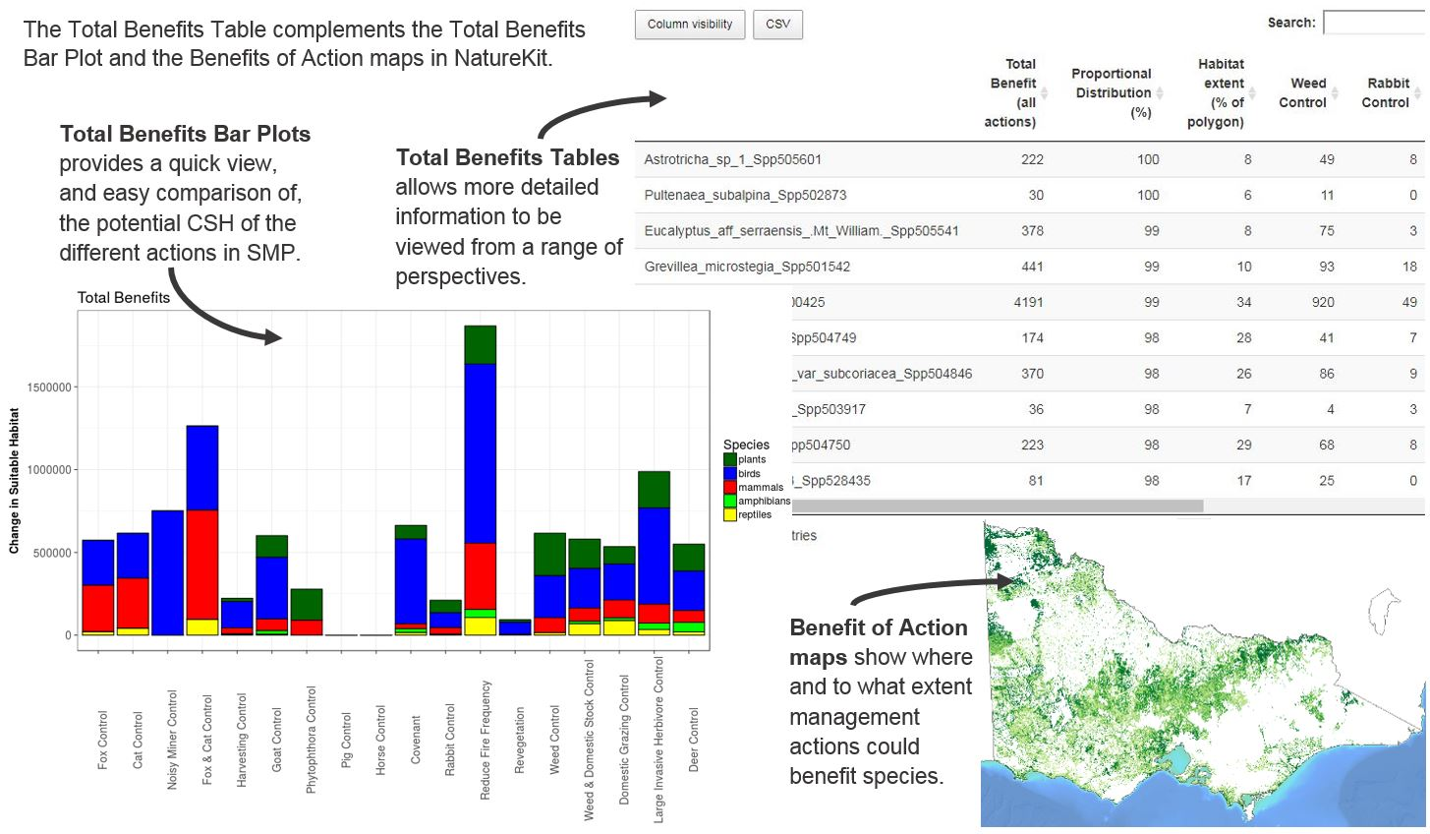

You can explore the benefits information in this table by filtering for a single species, turning on/off columns, sorting columns, or exporting the data.

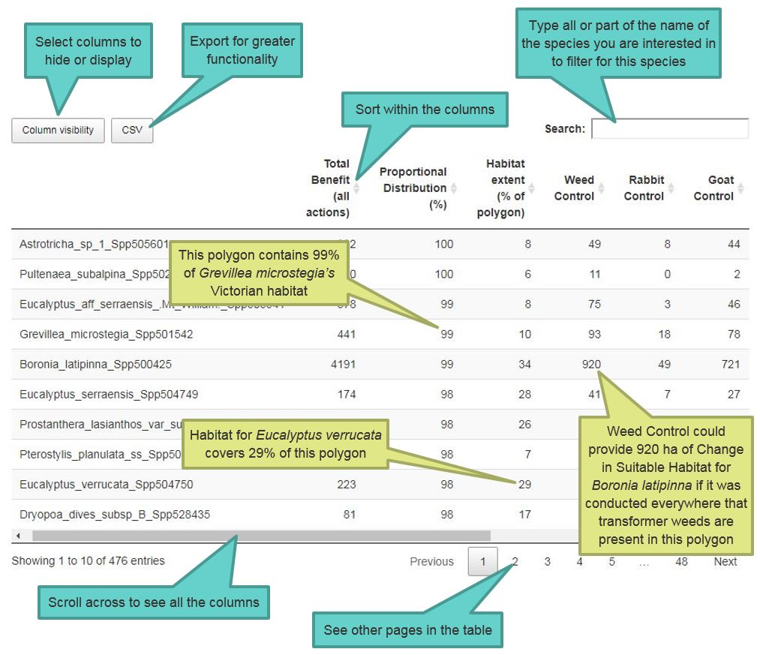

For more information about Strategic Management Prospects visit <https://www.environment.vic.gov.au/biodiversity/natureprint>.

|  |  |
| --- | --- |
| © The State of Victoria Department of Environment, Land, Water and Planning 2018  LogoThis work is licensed under a Creative Commons Attribution 4.0 International licence. You are free to re-use the work under that licence, on the condition that you credit the State of Victoria as author. The licence does not apply to any images, photographs or branding, including the Victorian Coat of Arms, the Victorian Government logo and the Department of Environment, Land, Water and Planning (DELWP) logo. To view a copy of this licence, visit http://creativecommons.org/licenses/by/4.0/  Disclaimer  This publication may be of assistance to you but the State of Victoria and its employees do not guarantee that the publication is without flaw of any kind or is wholly appropriate for your particular purposes and therefore disclaims all liability for any error, loss or other consequence which may arise from you relying on any information in this publication. | Accessibility  If you would like to receive this publication in an alternative format, please telephone the DELWP Customer Service Centre on 136186, email [customer.service@delwp.vic.gov.au](mailto:customer.service@delwp.vic.gov.au), or via the National Relay Service on 133 677 [www.relayservice.com.au](http://www.relayservice.com.au). This document is also available on the internet at [www.delwp.vic.gov.au](http://www.delwp.vic.gov.au). |

To view SMP products go to <https://naturekit.biodiversity.vic.gov.au>.