Introduction
Biodiversity Response Planning (BRP) is a long-term area-based planning approach to biodiversity conservation in Victoria. It is designed to strengthen alignment, engagement and participation between government, Traditional Owners, non-government agencies and the community.
DELWP Regional staff have been working with stakeholders on actions to conserve biodiversity in specific landscapes, informed by the best available science and local knowledge.
These Fact Sheets capture a point in time, reflecting data and knowledge available in 2020. They provide information for many (but not all) landscapes across Victoria, containing general information on the key values and threats in each area, as well as the priority cost-effective actions that provide the best protection of biodiversity. Fact Sheets are intended to provide useful biodiversity information for the community, non-government and government organisations during project planning and development.
Further information and the full list of Fact Sheets is available on the Department’s Environment website.

Landscape description
This focus landscape is 21,163 hectares in size and covers the area of Mt Budd to Mt Broughton. Of this, 51% is covered by native vegetation, and 10% is public land. Key natural features within this landscape include Switzerland Range Nature Conservation Reserve, Caveat Nature Conservation Reserve, Molesworth Bushland Reserve, Mafeking Rover Park, Dropmore G46 Bushland Reserve and Yarck Nature Conservation Reserve.

Cultural importance
We recognise that the entire landscape has high cultural value for Traditional Owners. Landscapes identified as having “notable” cultural importance is based on the density of recorded cultural heritage sites and knowledge shared by Traditional Owners. We also recognise that there are locations important to Traditional Owners not within this focus landscape. This area falls within the Country of the Taungurung Peoples.

Stakeholder interest
As part of the Biodiversity Response Planning process, in October 2020 stakeholders were asked to nominate focus landscapes and actions of interest. DELWP, Parks Victoria, Trust for Nature, Goulburn Broken Catchment Management Authority, North East Catchment Management Authority, Taungurung Land and Waters Council, Yorta Yorta Nation Aboriginal Corporation, and the Alpine Resorts agreed on this nominated area.

Possible future investment/project development in this landscape will be available to any interested stakeholders in addition to those who nominated this landscape.

Traditional Owners, stakeholders and community groups identified the following species of interest
- Matted Flax Lily (Dianella amoena)
- Golden Sun Moth (Synemon plana)

Strategic Management Prospects
Strategic Management Prospects (SMP) models biodiversity values such as species habitat distribution, landscape-scale threats and highlights the most cost-effective actions for specific locations. More information about SMP is available in NatureKit.

Additional threats
Threats (in addition to those modelled in SMP) identified through the consultation process were shrub colonisation by Burgan and hill (steep slope) erosion, thereby making revegetation an important conservation action. Permanent protection is important for species that are not well-recognised, such as derived grasslands. Management of stock grazing is also an important conservation activity.
Some individual threatened species may also require targeted intervention which goes beyond actions to manage landscape-scale threats, to improve their future prospects.

Which landscape-scale actions are most cost-effective in this landscape?
The coloured areas on the map below indicate where identified landscape-scale actions and locations are most cost-effective and will maximise biodiversity benefit across Victoria for multiple species.
The SMP priority actions which rank among the top 10% for cost-effectiveness of that action across the state for much of the landscape are in order of the top 3 actions listed - see map and list below:
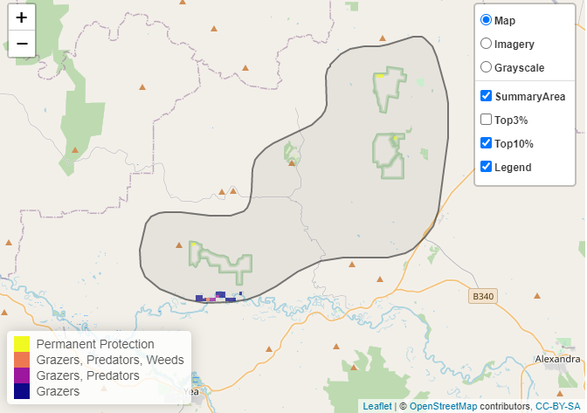

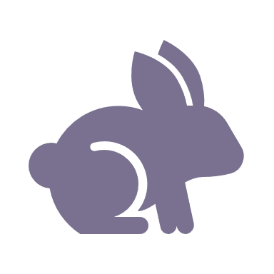 | Control rabbits 91 hectares
 | Combined cat and fox control 20 hectares
 | Permanent protection 20 hectares

Of the top 10% of cost-effective actions, controlling rabbits provides the most cost-effective biodiversity benefits when considering conservation of all flora and fauna.

The most cost-effective action for flora and fauna
Plants, Birds, Amphibians and Reptiles – Control rabbits
Mammals – Combined cat and fox control

For a further in-depth look at SMP results for this landscape please refer to NatureKit.

